REPUBLIC OF KAZAKHSTAN MINISTRY OF INVESTMENTS AND DEVELOPMENT COMMITTEE FOR ROADS

RESETTLEMENT ACTION PLAN FOR UZYNAGASH-OTAR ROAD SECTION OF ALMATY-KORDAY-BLAGOVESHCHENKA-MERKE-TASHKENT-TERMEZ ROAD OF THE WESTERN EUROPE – WESTERN CHINA ROAD CORRIDOR OF
SOUTH - WEST ROAD PROJECT (P099270)

ZHAMBYL DISTRICT OF ALMATY OBLAST AND
KORDAI DISTRICT OF ZHAMBYL OBLAST

FINANCED BY INTERNATIONAL BANK FOR RECONSTRUCTION AND DEVELOPMENT AND THE REPUBLIC OF KAZAKHSTAN

Prepared for: | Prepared by
Committee for Roads  Ministry for Investments and Development  Republic of Kazakhstan  47, Kabanbai Batyr Ave. | PMC KazdorNII/Sapa SZ  21 Manatau str., office 10  E-mail: pmc_kazdornii@mail.ru  Tel: +7 7172 578117

MAY 2018

Resettlement Planning Document

Document Title:  Document Stage:  Prepared on:  Updated on:  Language of Document: | Resettlement Action Plan  Draft (for consultation)  January 2017  May 2018  English (translated)

Country :  Project Code :  Project Title :  Project Section :  Section, km : | Republic of Kazakhstan  P099270  SOUTH-WEST  UZYNAGASH - OTAR  63-159

Prepared by the Committee for Roads of the Ministry for Investments and Development, by the Government of the Republic of Kazakhstan for International Bank for Reconstruction and Development (IBRD).

The land allocation and resettlement plan is a borrower's document. The view expressed in this document does not necessarily reflect the views of the Board of Directors of the IBRD, the Office or the personnel and may be provisional.

Table of Contents

ABBREVIATIONS 5
GLOSSARY 6
EXECUTIVE SUMMARY 7
1. Introduction and the Background 9
1.1. Project Description 9
1.3. Current Status and Project Implementation Conditions 11
1.4. Objective of the Resettlement Action Plan 12
1.5. Approach and Methodology 12
1.6. Identification of Project Affected Persons 12
2. Legislative Framework for the Land Acquisition and Involuntary Resettlement 14
2.1. Legal Framework in Kazakhstan 14
2.1.1. Constitution 14
2.1.2. Civil Code 14
2.1.3. Land Code 14
2.1.4. The Law On the State Property 15
2.2. WB’s Involuntary Resettlement Policy 17
2.3. National Laws and WB’s Policy Gap Analysis 17
3. Social and Economic Characteristics of the Region 22
3.1. Social and Economic Characteristics of Project Area 22
3.2. Profile of Affected Population 23
3.2.1. The Number and Size of Affected Households 23
3.2.2. Age, Family Status and Education Level of Head of Affected Households 23
3.2.3. Ethnic Composition of Affected Population 24
3.2.4. Incomes of Households 24
4. SOCIAL IMPACTS AND RISKS IDENTIFIED 25
4.1. Physical and Economic Impacts 25
4.2. Loss of Lands 25
4.3. Loss of infrastructure 26
4.4. Impact on Vulnerable Groups/People 26
4.5. Potential Construction Induced (Temporary) Impacts 26
4.6. The Project Affected Parties 26
5. Land Acquisition, Compensation and Mitigation Measures 28
5.1. Entitlement for Compensation 29
5.2. Process of Property Valuation 30
5.3. Provision for land users without formal land rights and open access land users 34
6. PUBLIC CONSULTATIONS 36
Participants and total number 36
7. GrievanceS Redress Mechanism 38
7.1. Levels and Procedures of Grievances Redress 38
7.1.1. GRM: Regional (Oblast) Level 38
7.1.2. GRM: Central Level 39
7.1.3. GRM: Legal System 39
7.1.4. Grievance Coordinators 40
7.1.5. GRM monitoring and reporting 40
7.1.6. Information Disclosure 40
8. INSTITUTIONAL Arrangement 41
8.1. Committee for Roads 41
8.2. NC KazAutoZhol JSC 41
8.3. Akimats 42
8.4. Project Management Consultant 42
8.5. Construction Supervision Consultant 43
8.6. Other Authorities and Agencies 43
9. MONITORING AND Evaluation Procedure 45
10. BUDGET 46
ANNEXES 48
Annex 1 48
Annex 2. 49

Figures

Figure 1. Uzynagash – Otar section layout 11
Figure 2. Proposed bypass layout 11
Figure 3. RAP Implementation Arrangement 41

Tables

Table 1. Comparison of Two Sets of Principles 18
Table 2. The Size of Households Surveyed 21
Table 3. Age of the Surveyed Heads of Households 21
Table 4. Education of the Surveyed Heads of Households 22
Table 5. Monthly Income of the Surveyed Household (per member) 22
Table 6. Impact Level 24
Table 7. Land Plots Permanently Acquired 24
Table 8. Data on Affected People by Categories 25
Table 9. Entitlement and Compensation Matrix 30
Table 10. Land Acquisition Implementation Schedule 32
Table 11. Consultations Summary Matrix 34
Table 12. Indicators and Methods of Internal Monitoring 43
Table 13. Documentation-Related Expenses (Administrative Costs) 44
Table 14. Overall Budget for Land Acquisition 45

ABBREVIATIONS

ADB | Asian Development Bank
AP | Affected People
CR | Committee for Roads
MID | Ministry for Investment and Development
IDB | Islamic Development Bank
EBRD | European Bank for Reconstruction and Development
GRP | Gross Regional Product
EBRD | European Bank for Reconstruction and Development
IFI | International Financial Institutions
KZT | Kazakhstan Tenge
LARF | Land Acquisition and Resettlement Framework
LARS | Land Acquisition and Resettlement Survey
NGO | Non-Government Organization
PAP | Project Affected Person
OP | Operational Procedure
PMC | Project Management Consultant
CSC | Construction Supervision Consultant
CC | Construction Contractor
PIB | Public Information Brochure
RAP | Resettlement Action Plan
GRM | Grievance Redress Mechanism
RK | Republic of Kazakhstan
ROW | Right of Way
TOR | Terms of Reference
WB | World Bank
WE-WC | Western Europe Western China
ORM | Operational Requirement Management
RPF | Resettlement Policy Framework

CURRENCY RATE
(as of May 18, 2018)
Currency Unit – Tenge (KZT)
KZT 1.00 = $0.0031
$1.00 = 327.11 KZT

NOTE
In this report
USD means United States Dollar
KZT means Kazakhstan Tenge

GLOSSARY

Affected  Persons | People, Households, or Legal Entities affected by project related changes in use of land, water, natural resources, or income losses.
Compensation | Payment in cash or kind to which the Affected People are entitled in order to replace land or other assets taken for project use.
Cut-off-date | Date after which people WILL NOT BE considered eligible for compensation, i.e., they are not included in the list of APs as defined by the census.
Encroachers | People who move into the project area, or who have trespassed into government land adjacent to their own, after the cut-off date and are therefore not eligible for compensation or other rehabilitation measures provided by the project. Persons informally using or occupying land prior to the cut-off date are eligible for compensation or alternative forms of assistance.
Entitlement | Entitlement means the range of measures comprising compensation in cash or kind, relocation cost, income rehabilitation assistance, transfer assistance, income substitution, and business restoration which are due to APs, depending on the type, degree and nature of their losses, to restore their social and economic base.
Household | Household means all persons living and eating together as a single-family unit and eating from the same kitchen whether or not related to each other. The census used this definition, and the data generated by the census forms the basis for identifying a household unit.
Income  Restoration | Income Restoration means re-establishing productivity and Livelihoods of APs.
Involuntary  Resettlement | Any resettlement, which does not involve willingness of the persons being adversely affected, but are forced through an instrument of law.
Land  acquisition | Land Acquisition means the process whereby a person is compelled by a public agency to alienate all or part of the land she/he owns or possesses, to the ownership and possession of that agency, for public purposes in return for fair compensation.
Rehabilitation | Assistance provided to affected persons to supplement their income losses in order to improve, or at least achieve full restoration of, their pre-project living standards and quality of life.
Socially  Vulnerable  People | Population, who have income less then living wage, or have other sources of personal vulnerability to hardship in adapting to changes caused by the project. Operationally, this is defined as people eligible for State Targeted Assistance, as per January 2011 information from Statistic Department of Almaty region.
Landowner | Physical or legal entity, which uses land plot based on the right of private property, i.e. has purchased the right for property from the state.
Lease-Holders | A person or a legal entity who holds a right of leasing the land (long or short term) on a contractual base. Typical long-term lease is 49 years.

EXECUTIVE SUMMARY

This Resettlement Action Plan (RAP) is prepared for Uzynagash - Otar road section located between km 63 and km 159 that is a part of Almaty-Kordai-Blagoveschenka-Merke-Tashkent-Termez road corridor in the Republic of Kazakhstan. The RAP includes an assessment of the project impact on the parties, resulting from involuntary land acquisition, a description of the social and economic status of the people whose lands are to be permanently acquired for construction purposes, an outline of the national legislation, the World Bank Operational Policy and comparison table for these two involuntary land acquisition-related frameworks, property evaluation and compensation processes, entitlement and compensation matrix, public consultations and disclosure of information, institutional arrangements, grievance redress mechanism, land acquisition timeframe and monitoring and assessment framework.

Project description. This project is a part of the current Government program for reconstruction of Western Europe – Western China Corridor International Transit Corridor. The reconstruction of Uzynagash-Otar road is financed by loan provided by the World Bank to the Government of the Republic of Kazakhstan within the frameworks of South-West Road Project. The civil works on this section will include widening two-lane road of Category II to four-lane asphalt-paved road of Category I. Civil works will also include three bridges, four interchanges, two bypasses, and replacement of existing culverts. Modernization of this road section will allow the flow of transport with axial load of 13 tons per axis, moreover the speed limit will become possible of 120 km/h. The new road will be constructed on the existing one within the existing right-of-way which is 40 m.

This RAP is prepared to mitigate the project adverse impacts on people living in proximity to the area of reconstruction and who are likely to be affected by the land acquisition required for permanent construction purposes. The detailed design prepared by the government institutions and subsequent Social Impact Assessment including analysis of census and public consultations have been used for RAP preparation. It describes the scope and scale of land acquisition, impact mitigation measures, regulating laws and mechanisms, measures to identify all affected people who require compensation or assistance, considers all affected parties, properties, titles, social and economic analysis and so forth. The guiding principles and standards for compensation based on the legislations approved by the Committee for Roads and the Bank policy requirements included in this RAP and applied to this Project.

Project impact. Although the reconstruction activities will be carried out within the existing right-of-way, the project will cause physical and economic displacement of one fuel station. Affected business is provided with cash compensation for loss of land and business. Other than this, acquisition of limited number of land plots is needed. In total, 13 parties are affected by the project, where 2 are registered organizations or legal entities and 11 are households and totally 15 land plots are acquired. All land plots are privately owned. Out of 15 land plots, affected by the Project, 10 are pastures (18.18 ha) and 5 of commercial category (1.13 ha). One plot has been entirely developed by the fuel station and to be acquired also entirely, land with the structure located on it (0.1 ha). The amount of compensation is KZT 34,020,017.00. No residential lands or structures have not been affected. Agricultural lands are used as pastures only, nor for farming. Private landowners of 8 land plots opted for cash compensation; landowners of 7 chose alternative land plot equal in quality, size and category. All land plots have been required for permanent acquisition only. The total amount of RAP is KZT 38,285,201.51 which in USD is 117,040.78.

While the land acquisition in the road project is required permanently, some temporary impact also may be expected, for instance construction by Contractor of the field office and other associated structures. It is resumed that temporary impacts will be limited by the period from six to twelve months on this road section. If longer or temporary acquisition turns to permanent, then entitlements for compensation obtained when land acquired temporary will not be reduced. In addition to the construction-related structures, the civil works may impede passing of cattle and pedestrians. If so, the Contractor will provide for alternative access to cattle crossings and pedestrian crossings if agreed by the local population.

Social and economic status. Social survey (census) has been carried out among the affected households to identify social and economic characteristics, project area, affected populated localities, composition and socio-economic status of families affected by the project.

Out of 11 households 8 were available during the census survey. The rest of 3 households was and remains unavailable, despite akimats and project consultants’ best efforts to contact them. None of the heads or other members of their families could be reached for communication. Half of households surveyed (50%) consist of 4-6 members, while families with less than 3 and more than 7 are 25% each. 2 out of 8 surveyed households are women-headed. The average size of a household is 4 people. All 8 households surveyed have been consulted by the Committee for Road and aware of the road widening and likely impacts to their lands.

Income sources of the households are salary (wages) and animal husbandry. None of them are dependent on commercial activities or government social support. Almost all households have more than two breadwinners. Half of the households (50%) has monthly income between KZT51,000 – 100,000, while 25% earn from KZT151,000 to 200,000, and 12,5% and 12,5% earn extremes in salary amount of KZT 50,000 or less and more than KZT201,000 per month respectively. Average monthly salary is more than KZT100,000 (USD305) which is over the national poverty line, determined as 40% of the minimum subsistence level which is KZT28,784.00 per person as of January, 2018 and no vulnerable households among the project affected parties.

The first public consultations regarding the proposed Project have been carried out during the development of the preliminary design in March 2015. Representatives of the Committee for Roads, akimats of Almaty and Zhambyl oblasts and designers took part in consultations held in Akshi village of Kurty rural district and Sarybastau village of Aidarly rural district to provide the basic information on the Project, impacts and issues of the RAP. The second public consultations were held in May 2016 in villages Sarybastau and Kenen and the third and final public consultations were held in April 2017 also in Sarybastau and Kenen villages. Information on the road section project, approaches to and aspects of land acquisition and resettlement, requirements of IBRD to resettlement, entitlements for compensation, procedures of grievance redress, data collection and other processes under RAP, and monitoring has been presented during these public consultations. Representatives of the Committee for Roads, NC KazAutoZhol, akimats, project consultants and the communities took part in these consultations

Grievance Redress Mechanism. A three-tier grievance redress mechanism has been established and functioning in all akimats that the road constructions are planned. The budget for resettlement on this stage includes only costs of formal registration of land plots and payment of taxes and duties. The final RAP will be translated into Russian and will be disclosed in English and Russian after obtaining clearance from the World Bank.

1. Introduction and the Background
- The Government of the Republic of Kazakhstan gives priority to the reconstruction of the transit route Centre West Corridor “Almaty-Kordai-Blagoveschenka-Merke-Tashkent-Termez” under the road reconstruction project Western Europe – Western China, and –Uzynagash-Otar Road Section, km 63 - 159 is part of the above road. This is the country’s principal link with the international transit corridor from China to Europe often characterized as the New Silk Road. The World Bank (WB), Asian Development Bank (ADB), Islamic Development Bank (IDB), European Bank for Reconstruction and Development (EBRD) and other international financial institutions (collectively referred to as IFIs) have been involved in this major task with the Committee for Roads, Ministry for Investments and Development (CR, MID) as the executing agency (EA) and the Akimat of Almaty Oblast as the Implementing Agency of the RAP.

1.1. Project Description
- Uzynagash – Otar road section, km 63 – km 159, with the total length of 95.376 km is a part of Almaty-Kordai-Blagoveschenka-Merke-Tashkent-Termez republican road. The road section is also a part of the Western Europe – Western China International Transit Corridor representing a necessary link in the international road corridor between Western Europe and Western China. The corridor is aimed to provide the separate road through Western China, Kazakhstan and the Russian Federation that allows travelling in any climate conditions. This corridor will increase economic benefit, significantly increase flow of the goods, tourists and improve social connection with the People’s Republic of China and the Republic of Kazakhstan.
- In 2006, this road section has already been reconstructed: km 14 to km 63 (49 km), to the Category I (4 lanes with two lanes in each direction, and median) and km 63 to km 162 (99 km), to the Category II (2 lanes with one lane in each direction).
- About 80% of the road section will be constructed on the existing road of much smaller size and worse quality, with widening of the road from 2 lanes to 4 lanes, or from Category II to Category I. The right-of-way of the road is 40 m. The new road will be constructed within the existing right-of-way. The existing three bridges will be also reconstructed with widening for the additional two lanes.

- The Project includes construction of two bypasses of villages Samsy and Targap. The length of alignment with cutoff is approximately 102,801 km (from km 56 to km 158+801). Cutoff and Samsy bypass is km 63+000 – 80+398 (17,071 km), and bypass of Targap is km 89+705 – 1000+000 (10 km).

- During the field survey conducted in October 22, 2014, all the detailed characteristics of the existing roads were studied and analyzed, including the proposed bypasses of Samsy and Targap villages. The drawings showed the proposed bypasses that will improve the alignment, road safety, reduce the number of traffic accidents and reduce the length of the road and provide the opportunity of future expansion of the settlements located near to bypasses. The proposed bypasses are optimal to ensure safety near villages and are likely to positively affect the future development of the growing population, including social and economic development of two villages.
- The Project includes construction of artificial structures (cattle crossings, culverts, bridges, etc.) those are already agreed with the local authorities (akimats) and heads of peasant households. The works on 4 traffic interchanges at different levels, 2 of the trumpet type at km 59+120 are included.

- Along Uzynagash – Otar road section the artificial structures for maximum amount of rainfall floods are presented by round and box culverts of various diameter and sizes. All culverts have been constructed in 2004 and are in quite good operating condition. The Project provides for replacement of the old culverts with the new bigger ones and some additional culverts will be provided if required.

- There are no natural habitats, ecosystems or sensitive habitats along this section. The road area is fed by surface water. The main sources are five rivers, namely Karasu, Kurozek, Samsy, Zhyrenaigyr and Targap located in the road area. The rivers are supplied with water from mostly ground and atmospheric and water levels depend on the annual amount of precipitation. The extent of mineralization in spring is small, and it goes up in summer and winter. The groundwater of modern Quaternary and Paleozoic sediments that lie at great depths predominates in the region. Groundwater is widespread. The depth of it varies from 2 to 10 meters. It is fresh in terms of quality. In some places, the alluvial cone base groundwater wedging out forms spring and wetlands (saz). In spring and summer, floods occur on many rivers, which results in flooding of bridges. Spring and mud floods of mountain rivers carry large amounts of gravel and sand deposits. On the exit from the mountain, water from the rivers is intensively taken for irrigation. The average level of the road section is 600 meters above sea level, where maximum is 560 and minimum 640 meters.

- The right-of-way of the existing road is 40 m. Due to the expansion of the road, and according to preliminary estimates the land acquisition is required along the road section and proposed bypasses. Some agricultural and commercial lands will be affected along the section.

- Condition of the existing road according to the parameters of the plan, longitudinal and cross section profiles does not meet the requirements of technical category Ib according to SNIP RK 3.03-09-2006*. Working designs of "Western Europe-Western China‖ corridor reconstruction", "Uzynagash-Otar‖ sections km 63-101 and km 101-143 of "Almaty-Kordai-Blagoveschenka-Merke-Tashkent-Termez" republican road were developed by the institute LLP "PII Kazdorproject" based on assignments of Almaty regional branch of JSC "National company "KazAvtoZhol".

- Further, km 143-159 of the republican road "Almaty-Kordai-Blagoveschenka-Merke-Tashkent-Termez", was developed by the Design Institute LLP "SK Engineering" based on Assignment of Zhambyl regional branch of JSC "National Company "KazAvtoZhol".

- For development of working design institute LLP "PII" Kazdorproject" and LLP "SK Engineering" conducted complex topographic survey and geotechnical investigations in 2015-2016.

- The relevant approval procedures were duly carried out: land acquisition for the road, location of new culverts, approval of relocation of utilities with their owners and water collection from local sources for technical needs have been received. All approvals have been discussed and accepted during public consultations. In addition, designs shall be approved by the local executive authorities in accordance with the current legislation of RK, which is one of mandatory requirements of the State expertise.

1.2. Project Location

- The existing "Almaty-Kordai-Blagoveschenka-Merke-Tashkent-Termez" road km 63 - km 159 runs through Zhambyl district of Almaty oblast and Kordai district of Zhambyl oblast of Kazakhstan.

- Uzynagash-Otar road section begins at the north-west from Almaty in Uzynagash village (km 63) and ends near Kordai bypass at km 162 in Otar village. The road runs through the highlands, plains and hilly terrain in the northern direction. The road starts at an altitude of 765 m, goes through a flat terrain on Karatorpak gorge, descending to 685 m, and then running up to 27 km in hilly terrain with several passes with elevations up to 760 m, the last pass leads to a dropdown valley.

- Samsy and Ungurtas villages are located 13 km and 18.50 km respectively away from the end of four-lane road, namely from 57 km road stretching from Almaty through Uzynagash towards Otar. Villages like Ulguli, Ungurtas, Targap, Kopa, Degeres, Beriktas are also located along the road between Uzynagash and Otar.

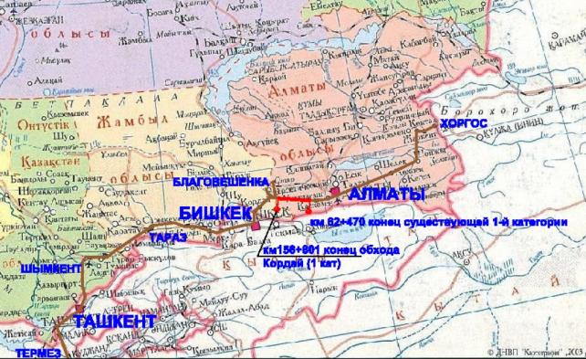
Figure 1. Uzynagash – Otar section layout
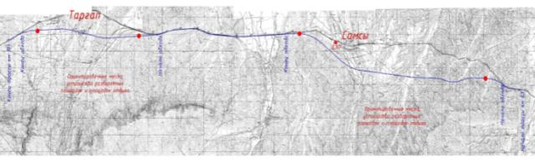
Figure 2. Proposed bypass layout

1.3. Current Status and Project Implementation Conditions
- The proposed project includes land acquisition and construction induced impacts, which are expected to be minimal in the project of road with length of 96 km. Just a few landowners are impacted by the proposed reconstruction of the 4-lane road corridor. The road construction works are expected to begin in June 2018 (only after RAP is approved by the Bank) and the subsequent procedures provided for by the Republic of Kazakhstan. RAP will be fully implemented before the beginning of any construction activities.
- Currently, for this road section, land re-configuration has been implemented (i.e. alternative land plots will be given to affected people. The Akimat has already had negotiations with the affected land owners and they agreed for alternate land lots. Such land re-configuration included shifting coordinates of land plots without any changes to title documents, namely coordinates have been moved to vacant government land plots. Akimat issued a decree on August 11, 2016. The decree identifies land areas to be added to existing land reserve, and working land areas to be acquired for permanent use in the amount of 19.31 ha. The project RAP covers all 19.31 ha of land acquisition. The date from which all formal land users were identified is August 11, 2016 and which is considered as the final “cut-off date”. For all the informal users, the cut-off date was the social/census survey date for the RAP preparation - August 11, 2016.
- This RAP describes the scope and scale of land acquisition required, as well as the main provisions and procedures followed. The RAP compares this process with the main provisions and procedures set out in RPF, agreed between the Bank and the Committee for Roads in November of 2015 to identify gaps those could arise. In addition, RAP determines measures to identify all persons whose interests have been affected which may require different forms of additional compensation or necessary assistance harmonize land acquisition process with the agreed standards.

1.4. Objective of the Resettlement Action Plan
- The objective of this RAP is to prevent and mitigate adverse impact on people, their property and livelihood activities in the development process. The Resettlement Action Plan for km 63 – km 159 Uzynagash - Otar road section is designed to mitigate potentially adverse project impacts. It describes the remedial measures necessary for mitigation of adverse impacts.

1.5. Approach and Methodology

- To achieve the objective of this Resettlement Action Plan, systematic, participatory and collaborative approaches have been adopted. Methodology to collect information included a desk review of the project documents and design drawings, study of alignment maps, a census of project affected people, public consultations, interviews with key affected persons, questionnaire survey, field investigations and consulting the local executive authorities.
- Akimat issued the Decree dated of August 11, 2016 indicating the land plots required to be added to the existing reserved lands, as well as working areas require for permanent acquisition includes 19.31 ha.

1.6. Identification of Project Affected Persons
- Process of identification of structures and land plots affected by the project is based on three methods:

- Identification of official land users: Two instruments have been used to identify land users: (1) the existing cadastre and land use data available from the oblast branch of State Corporation “The Government for Citizens” (NPCzem); and (2) a 1: 2,000 survey maps conducted by designers in each site, where all the buildings are indicated, and which are tied to coordinates, 120 m wide, following the road route plan. It will show all the facilities within the existing right-of-way, where work will be carried out.
- Identification of Informal Land Users: Land use surveys along the entire route plan have been carried out by designers to identify and describe any forms of informal use of the Right-of-Way or Territory affected by construction of bypass roads or other land acquisition that do not affect visible structures and they remain unnoticed in the methods described above for the definition of formal structures. This type of land user includes, for example, informal agricultural enterprises (gardens, small fields, seasonal outlets), facilities for the cultivation of animals and birds that are illegally located in the right-of-way.
- Information on any registered site and its location with topographic coordinates is kept in the Real Estate Centers of the Ministry of Justice. This information is also collected by the State Corporation “The Government for Citizens” (NPCzem). Designers involved by CR have received information about landowners who may be potentially affected from the State Corporation “The Government for Citizens” (NPCzem) in the form of maps with a scale of 1:25 000 showing the projected road and land plots intersected by the road or located in close proximity to it. The designers compared these maps to the information they received during topographic surveys on the route, performed as standard measures in their work.

- In order to identify informal land users, the designers compared the official land use data received from NPCzem with their own data from the latest surveys. Thus, each designer has the possibility to identify structures erected (usually within the right-of-way) illegally and without registration of ownership.
- In addition, to verify and determination of impacts, a census survey and public consultations have been carried out to obtain specific details of project affected parties/households. All affected structures/assets shall be compensated, independently from their legal status.

2. Legislative Framework for the Land Acquisition and Involuntary Resettlement
- The Legal Framework Section of this RAP describes all laws, decrees and regulations of the Republic of Kazakhstan related to the resettlement and land acquisition activities associated with the project, as well as IBRD’s Involuntary Resettlement Policy and fundamental principles. Legislation is presented in hierarchical order. Since physical involuntary displacement of community is not required in this project, the Laws and Regulations presented are related to land acquisition, entitlements, state property, including the summary of procedures.

2.1. Legal Framework in Kazakhstan
- Land in Kazakhstan mainly is owned by the Government. However, the lands may be privately owned, transferred, sold or rented by individuals. When land is in private ownership, the Government may claim it back for the special use only, including road construction. Any ownership deprivation shall be carried out in accordance with the governing procedures provided by the Codes and Laws and after payment of compensation for all losses to affected people. Some of the main regulations related to land acquisition for public interests and needs are the Constitution of the Republic of Kazakhstan, the Land Code, the Civil Code, and the Law “On the State Property”.

2.1.1. Constitution
- Laws and regulations related to land and land ownership in Kazakhstan are primarily based on the provisions of the Constitution.
- Article 6.3 states that land (above and below the surface) belongs to the Government, but may also be privately owned.
- Article 26.3 states that ‘No one may be deprived of his ownership unless stipulated by a court decision. Any forced deprivation of ownership for public use can be carried out subject to equal compensation, in exceptional cases, provided by the Law’.

2.1.2. Civil Code

- The Civil Code, Clauses 4 and 5 of Article 9, states that compensation amount shall include cost of the property and full amount of losses incurred by a landowner/user as a result of forced land acquisition for public use and (or) premature termination of the obligations of an owner or non-state land user to third parties.

- Currency of compensation shall be Kazakhstan Tenge.

- If the landowner/user agrees, he/she may be provided with an alternative land plot of equal value or titles on it. This cost is based on cadastral (estimated) cost in replacement of land acquired for public needs.

- Compensation shall be paid in full amount before ownership rights on this property are transferred to the Government.

2.1.3. Land Code
- The Land Code No. 442 dated of 20th of June 2003 provides for the land reservation for public needs stating in Article 84.1 that ‘land plot may be reserved for public needs by purchasing it or providing equivalent land plot to a landowner or land user with their consent’. Article 84.2.4 states that road construction is one of those public needs and private land may be acquired by the Government. Article 84.4 indicates that when land plot is leased, the lease contracts are prematurely terminated, then compensation is paid to the lease-holder in amount sufficient to cover all losses and the lease-holder may be given an alternative land plot, if available.
- Involuntary acquisition of land plot or any property is an exceptional case of deprivation of an individual and a legal entity of their ownership rights and that can exclusively be accepted when there are no other options to satisfy public needs.
- The Land Code also distinguishes the nature of public needs and private commercial purposes where the latter relates to land acquisition by nongovernment legal entities in pursue of their commercial interests and without performing any public functions. In that case, the deed between seller and buyer is confirmed by the contract.
- The amount of land for acquisition shall not exceed amount of land required to meet public needs.
- Before the beginning of involuntary land acquisition, the Government or local executive body (further - Akimat) issues a decree about the beginning of land acquisition process. This decree shall include:
- The aim and justification of land acquisition;
- Location, oblast, cadastral number;
- Property owner or user;
- Date of acquisition (no earlier than 3 months after the date of this decree);
- Place where landowner or user can come to perform conciliation procedures.

- In case if any changes are introduced in clauses 2 and 4 the procedure of the land acquisition is to start again from the date of Amendments introduced in the decree.

- These decrees shall be published in the national and local mass media within three working days after they are signed.
- In case when private ownership is not registered, the landowner may arrange for the proper and necessary registration of private ownership for the land plot in subject after the decree is signed.
- At that the term for forced land acquisition determined by the decree shall be extended for no more than six months.
- Regarding compensation, the Land Code offers a choice to landowner/user, namely alternative land plot/property can be provided instead of monetary compensation. Although these alternative lands are not always easily accessible, affected people shall be properly informed about such option.

2.1.4. The Law On the State Property
- The Law “On the State Property”, Chapter 6, is the main governing regulation related to involuntary land acquisition for public use that describes all aspects of the land acquisition procedure. The Law specifies the subject, general provisions, the principles, start and end of such land acquisition, the manner of notification and procedure of land acquisition, titles of the owner, the amount of compensation, form and dates of compensation payment, and conciliation procedures as well. All necessary procedures are carefully set out in this Law in details. There are important provisions outlined below.
- Executive body shall send a written notification to the landowner/user within three calendar days after publication of the decree that his land plot is subject to acquisition for public use. Together with notification the landowner/user receives the draft contract on purchase of this land plot or other property. The notification shall be sent by mail with written confirmation of its receipt. In case of no written confirmation of the notification receipt, the documents shall be sent again.
- The Law describes the procedure of land acquisition. The basis of forced acquisition of land or other property for public needs is a Contract on land acquisition, or court decision.

- The local executive body (Akimat) shall send to the relevant representative body the draft contract for land acquisition or property within two months from the moment of notification received by the landowner or user. The permanent commission of the local representative body within two weeks reviews the draft contract in presence of the landowner or people whose rights are to be terminated or limited. After agreement is achieved, executive body approves the contract and then the landowner or user signs it. Such contract as ascribed by the Law shall include the following information:

- Cost of the land plot, determined pursuant to this Law, Article 67, and identification characteristics of the immovable property or land plot provided to the landowner or user instead of acquired one;
- Difference in cost possible if alternative land is of less value;
- Amount of losses to be compensated, including cost of property acquired;
- Dates of payment for the land plot/property or transfer of alternative land plot to the landowner/user;
- Composition of the property acquired for public needs;
- List of people whose titles to land are to be terminated or limited;
- Information about funding such land acquisition for public use by the Government.
- If the landowner/user does not agree with the decree on land acquisition issued by the Government or local executive body, cost of the land acquired or amount of losses to be compensated, the local executive body can file a claim in court for involuntary acquisition of land or property for public needs. Such claim shall be filed after three months from the date of land acquisition notification received by the landowner/user but not later than the date of beginning of land acquisition process. The court will consider such civil cases of involuntary land acquisition within one month. If this law case is denied, all damages caused to the landowner/user shall be covered by the Government.
- The actual transfer of the land plot or property can only be carried out after the landowner/user receives compensation in a manner set out in this Law. Termination of the ownership/lease title shall be officially registered given that a document confirming payment of compensation to the landowner/user is provided to the registering authority.
- The landowner/user may use his titles and perform all necessary expenses related to the use of land or property based on their intended purpose from the moment of notification about the beginning of land acquisition is received and until the cost and losses to be compensated are agreed, or the court decision taken. Meanwhile, the landowner/user takes risk of losses and damages related to new construction, expansion or reconstruction of buildings (structures and constructions) or other property during this period.
- The Law also specifies that if after acquisition of a part of the land the remainder becomes unusable in the same way as before, then the entire land plot shall be acquired.
- The cost of the acquired land plot which the landowner bought from the Government is determined in the amount paid to the Government, and cost of the estate property located on it is determined in the amount not exceeding its market price and determined by the independent valuator at the moment when the landowner/user receives notification about involuntary land acquisition.
- Compensation shall be paid from the Government budget based on the Contract for purchase of land plot or other property for public needs. Payment shall be made within one month after the Contract is signed or after the court decision becomes effective. Payment of compensation by installments is not allowed.

2.2. WB’s Involuntary Resettlement Policy
- In this section the main safeguard policies and principles of the World Bank related to involuntary resettlement applied in the development projects are described.
- World Bank Policy OP 4.12 (Involuntary Resettlement) describes the principles applicable for temporary and permanent impacts on households caused by loss of lands, buildings or others basic assets, change in land use or business, restriction for use of lands, accommodation or business. Principles shall be applied to all “affected people” including those who do not have formal legal licenses or property right, but experiencing impact resulted from land acquisition or resettlement for public needs. These principles are as follows:
- Land acquisition and resettlement shall be avoided or minimized;
- Affected people shall be entitled for compensation of full replacement cost for their lost assets, incomes and businesses, including temporary losses or impacts, without adjustments for depreciation or deductions for any other purpose;
- Compensation (and other forms of assistance, as warranted) shall allow affected people to improve, or at least restore their pre-project incomes and living standard;
- Affected people shall be consulted on resettlement planning;
- Affected people shall be fully informed of their compensation options;
- Land-for-land swap is the preferred compensation for lost agricultural land if it is available, unless an affected person chooses cash compensation;
- Costs of property transfer —purchase or swap—are waived or borne by the investor, including taxes, fees, documentation and court appeals;
- Compensation shall be made giving equal consideration to women and men;
- Lack of formal legal property right does not dispossess affected people from their entitlements or assistance required to achieve the objectives of the Policy;
- Affected people shall be supported during resettlement;
- Special attention shall be given to women-headed households and other vulnerable population and appropriate assistance provided to assure that their living standards are maintained or improved;
- Land acquisition and resettlement shall be implemented as a part of Project and fully funded;
- Compensation shall be fully provided until access for land is obtained to perform civil works or demolition;
- In case of unavailability of the landowner or heirship registration (or left the country), etc., the Government shall put compensation amount and 10% in ESCROW account.

2.3. National Laws and WB’s Policy Gap Analysis
- Table 1 demonstrates provisions of two legal frameworks related to involuntary resettlement and land acquisition, namely World Bank’s Involuntary Resettlement Policy and legal practices employed in Kazakhstan. While they mainly correspond with each other, some discrepancies can be seen in two approaches to land acquisition and involuntary resettlement, such as different approach in identifying the value of property acquired, cadastral in KZ and market value in WB. In addition, only those having legal ownership are entitled for compensation v/s compensation shall be paid for non-land property. Kazakhstan Laws do not include the requirement of restoration of livelihood or goals to improve living standards and ensure local population benefitting from the development project, or assistance provided to population with their moving to a new place. The World Bank also envisages involvement of independent valuator as third party in negotiations and carrying out external and internal monitoring while in Kazakhstan legislation there are no such requirements Please see below table 1.
Table 1. Comparison of Two Sets of Principles
No. | Land Plots Acquisition Practices in Kazakhstan | The WB Resettlement Policy | Agreement on this Project
1. | Compensation for the land plots that are privately owned is calculated based on the cadastral value, including the opportunity to exchange it for another land plot. | Compensation for the land plots that are privately owned is based on the total cost of the resettlement process as per market value (the full cost of replacement). | Alternative lands to be provided of equal size, quality and category, etc.
2. | Compensation for land and non-land property is specifically provided only to the entitled owners or tenants of land, who purchased out ownership or rights to lease from the Government. | Persons affected by resettlement (APs) without formal legal rights and claims are entitled for compensation for the non-land property (for example, in case of loss of plants, trees and structures). | In this Project non-formal users have not been identified. In case of changes in the design and non-formal users are identified, the requirements of the WB’s Resettlement Policy will be met. Specifically, PAPs without formal legal rights and claims are entitled to compensation for non-land assets (e.g. crop, tree and structure losses).
3. | The purpose does not specifically include restoration of livelihoods and standards of living. | The objective of the policy is to restore livelihoods and living standards of the APs, regardless of ownership right or legal status. | Depending on the situation, measures will be taken according to the Laws, which also meet the requirements of the WB policy. For example, according to Article 86 of the Land Code of the Republic of Kazakhstan, if the owner or a non-state land user after involuntary acquisition of a part of the land plot for public needs cannot use the remaining part for the previous intended purpose, then the entire land plot is acquired.
4. | There are no requirements to provide assistance to APs and examine their opportunities in resettlement process to benefit from the project. | Physically displaced persons (irrespective of their legal status in respect to the land) are provided with the following:  (i) assistance in resettlement, guaranteed ownership of the land plot, where they were resettled to, improvement of living conditions in the resettlement sites with comparable access to the previous employment and production capabilities, as well as civilian infrastructure and services, if necessary,  (ii) provision of support within the transition period and assistance aimed at development, such as land development, credits provision, training or employment opportunities, as well as  (iii) opportunities to obtain the relevant benefits from the project. | Depending on the situation, measures will be taken according to the Laws, which also meet the requirements of the WB policy.
5. | Compensation, other than compensation for the acquired property and loss of income from the lost business (including future losses), is not provided to support the economically resettled persons. | The economically resettled persons will be provided with the following:  (i) assistance (for example, access to credits obtaining, training and employment)  (ii) opportunities to obtain the relevant benefits from the project,  (iii) compensation for: (i) the cost of recovery of commercial activities in another site, (ii) net income lost during the transition period, and (iii) the cost of relocation and reinstallation of a plant, machinery and other equipment. | Depending on the situation, economically displaced persons will be subject to measures in accordance with the law, which also comply with the requirements of the WB policy. For example, according to Article 9 of the Civil Code of the Republic of Kazakhstan, the person whose right is violated may demand full compensation for the losses caused to him, unless otherwise stipulated by legislative acts or the contract.  Losses are understood as expenses that are incurred or must be incurred by a person whose right has been violated, loss or damage to his property (real damage), as well as lost incomes that this person would have received under normal conditions of turnover, had his right not been violated (lost profit).
6. | Census surveys and social impact assessments | Socio-economic research (studies) and the census in the presence of the relevant socio-economic data are necessary to identify all the APs and assess socio-economic impacts of the project on them. | The social assessments including census survey carried out as per the WB’s Resettlement Policy requirements
7. | Identification and assistance to vulnerable groups. | Identification of vulnerable groups and development of targeted measures to ensure that they are not subjected to adverse effects and are not at a disadvantage in terms of distribution of benefits and opportunities for development. | No vulnerable families/groups impacted by the project and Kazakhstan Law on Address Social Aid will be implemented in parallel with any additional assistance.
8. | There are no requirements for the RAP preparation and approval. Consultation with the APs is not required in relation to land acquisition. | Preparation, approval, disclosure of information and monitoring of the Resettlement Action Plan (RAP) based on consultation with the APs and social impacts assessment are required. | The WB’s Resettlement Policy is implemented and RAP will be implemented prior to start any project interventions
9. | The possibility of negotiations without a third party is considered as an initial approach to address land acquisition issues. If agreement cannot be reached, then involuntary acquisition procedures will be started through the court. | It contributes to land acquisition through negotiations, which must be confirmed by third parties, the independent valuator, in order to ensure appropriate compensation relevant for all the costs of relocation and substantial consultation with the APs. | The WB’s Resettlement Policy is implemented and the land to be acquired for the project will be obtained through consultations and negotiations process by providing compensations as per the Bank policy requirements. If the agreement cannot been reached then the procedures of involuntary acquisition through the court begin
10. | There are no requirements for internal or external monitoring | Depending on the category of the project, the WB requires both, internal and external monitoring | The WB’s Resettlement Policy is implemented
11. | The law and regulation of Kazakhstan does not provide provisions for establishing cut-off dates | Establishing the Cut-off date. Normally, cutoff date is the date the census begins. The cutoff date could also be the date the project area was delineated, prior to the census, provided that there has been an effective public dissemination of information on the area delineated, and systematic and continuous dissemination subsequent to the delineation to prevent further population influx. | As per the Kazakhstan Land code, the date of decree issued to land owners considered as the cut-off date. For informal land users the census survey date will be considered as the cut-off date as per the OP 4.12
12. | The law and regulation of Kazakhstan doesn’t provide provisions for establishing of project specific GRMs. However, there is a national requirement to establish a grievance mechanism in each public and administrative organizations. Akimat level there is a public relations and complaint handling system exists | Grievance Redress Mechanism. All WB financed projects should provide appropriate and accessible grievance mechanisms for PAPs. | In this project, the implementing agency will establish the project specific GRM which will be maintained and regularly monitored by the project.
 | The law and regulation of Kazakhstan doesn’t require disclosure of resettlement related documents but only environment reviews/assessment reports. | Disclosure of information. As a condition of appraisal of projects involving resettlement, the borrower provides the Bank with the relevant draft resettlement instrument which conforms to this policy, and makes it available at a place accessible to displaced persons and local NGOs, in a form, manner, and language that are understandable to them. Once the Bank accepts this instrument as providing an adequate basis for project appraisal, the Bank makes it available to the public through its InfoShop. After the Bank has approved the final resettlement instrument, the Bank and the borrower disclose it again in the same manner. | In this project, the implementing agency will ensure disclosure of all safeguards instruments (including social and environmental instruments) as required and guided by the Bank policy.
 |  | Treatment of assets / infrastructure on land acquired | All PAPs will be assisted in accordance with the Bank’s OP.
- In case of any discrepancies in two legal bases, the safeguard principles set out in the World Bank’s OP 4.12 (Involuntary Resettlement) shall prevail over national legislation, be applicable and adhered to when carrying out involuntary resettlement and land acquisition process. To avoid issues related to such discrepancies, the Government of Kazakhstan signed and ratified the Loan Agreement for road reconstruction with the World Bank, where the Government agreed to follow the WB’s principles in involuntary land acquisition of private land and resettlement of households in the public interests under this project. The principles are applied in case of temporary or permanent impacts on households resulting from loss of land, structures or other fixed assets; changes in land use or business; restrictions in the use of land, housing or businesses. The principles apply to all “project-affected persons”, including those without formal licenses or titles, who experience impacts as the result of land acquisition or resettlement for public needs.

3. Social and Economic Characteristics of the Region

3.1. Social and Economic Characteristics of Project Area
- There are villages Uzynagash, Samsy, Sarybastau, Ungurtas, Targap and Degeres located in the area the road to be reconstructed runs through.
- Uzynagash is a village in Zhambyl district of Almaty oblast of Kazakhstan, an administrative center of Zhambyl district and also administrative center of Uzynagash rural district. Uzynagash is located 43 km to the west from Almaty. There are two routes going to this village: Almaty - Bishkek road and the upper road along the mountain slopes. There are 3 settlements in the district: Uzynagash village (rural district center), Zhanakurylys village, and Yntymak village. The population of Uzynagash village is 41,089 people, where 19,542 are men and 21,547 are women, the land area is 41,439.22 ha, livestock number is 15,416 units. There are 7 schools in the district: Abai Secondary School, Berdikulov Secondary School, Ryskulov Secondary School, Valikhanov Secondary School, Nauryzbai Batyr Secondary School, Karsakbayev Secondary School, Yntymak Secondary School, as well as Boarding School. Number of students is 7,606, 12 kindergartens, 1 hospital, 2 rural outpatient clinics, 3 First Aid Stations (hereinafter referred to as FAS), 156 stores and 605 farms.

- Sarybastau is a village in Zhambyl district of Almaty oblast of Kazakhstan. It belongs to Ungurtas rural district. There are 4 settlements in the district: Ungurtas, Sarybastau, Akdala, Kokkainar, the center of the district is Ungurtas village. The population of Sarybastau district is 4,315 people, where 2,214 are men and 2,101 are women. The land area is 32,460 ha, livestock number is 4,444 units. There are 4 schools in the district: Ungurtas Secondary School, Sarybastau Secondary School, Akdala Secondary School with incomplete education, and Kokkainar Secondary School. The number of students is 589. There are 3 FAS, 2 production cooperatives (hereinafter referred to as PC), 2 limited liability partnerships (hereinafter referred to as LLP), 13 stores, 103 farms and 1 café. Ungurtas village is located 34 kilometers away from the district center – Uzynagash village.
- Samsy is a village in Zhambyl district of Almaty region of Kazakhstan. It is the administrative center of Samsy rural district. Samsy rural district includes three settlements: Samsy, Targap villages, and Kopa station. The population of Samsy is 3,503 people, where 1,701 are men and 1 802 are women, the land area is 32,460 ha, livestock number is 20,518 units. There are 3 schools in the district: T. Sarsenbekov Secondary School, Targap Secondary School, Kopa Secondary School with incomplete education. The number of students is 529. There are also 2 FAS, 1 PC, 3 LLPs, 20 stores, 90 farms and 2 cafés in the village. Samsy is located 23 kilometers away from the district center – Uzynagash village.

- Targap is a village in Zhambyl district of Almaty oblast of Kazakhstan. It belongs to the Samsy rural district. It is located about 40 kilometers to the west from Uzynagash village.

- There are 5 settlements in Degeres rural district: Degeres, Besmoinak, Bulak, Sunkar, Karaarsha, the district center is Degeres village. The population is 4,060 people, where 1,985 are men and 2,075 are women. The land area is 53 989 ha. There are 5 schools in the district: Ospankhan Aubakirov Secondary School, Zhangeldin Secondary School, Sunkar Secondary School, Bulak Elementary School and Karaarsha Elementary School. The number of students is 582. There are one rural outpatient clinic, 4 first aid stations, 1 kindergarten “Bobek and Bobekzhaiy‖”, 2 post offices, 5 stores, 2 toikhana (restaurants), 1 baths, 3 LLPs, 142 farms. Degeres village is located 65 kilometers away from the district center – Uzynagash village.

- In all villages above, local dwellers’ main livelihood activity is animal husbandry, in particular, the breeding of camels, cattles, horses, sheep and goats. Lands are used as pastures, and melons and gourds are grown on the land plots with fertile soil.

3.2. Profile of Affected Population
- To collect information on social and economic situation and life conditions of the affected households, and to make further assessment of impact of land acquisition, the secondary data has been collected from the government agencies, as well as social survey of 61% of AP (households) has been carried out. Formal and informal interviews have been conducted in February 2018 using questionnaires translated into Russian. Social and economic survey has been carried out based on the preliminary list of affected property and people, provided by design consultants.
- The findings showed that this road construction will impact on lands of 13 parties. 11 of them are households and 2 registered organizations (legal entities). Out of 11 households, 8 heads of households were interviewed for RAP preparation. Although all efforts have been taken by the akimats and project consultants to contact 3 households, they are out of reach and non-contactable. They do not live in the villages of Zhambyl district of Almaty oblast and are not registered in these villages. Committee for Roads and consultants several times contacted Akimat of Almaty oblast for their assistance in identification of location of these 3 households for survey, but their contact details (3 households which found unavailable for communication) which earlier had been used and the connection established were not available at the time of the survey. However, Akimat of Zhambyl district of Almaty oblast, based on negotiations conducted during the consultations with the land owners regarding compensation, and upon their will (3 households) offered to these 3 households the alternative land plots of similar quality and size and they agreed (land plots for them are reserved). They refused monetary compensation.

3.2.1. The Number and Size of Affected Households

- More than a half of households surveyed (50%) consist of 4-6 members, while households with 3 and less members as well as with 7-9 members compose 25% each. Out of 8 interviewed households, 2 were woman-headed. The average size of a household is 4 people. All 8 households interviewed have agreed to provide data on their households that has been used for analysis. See Table 2 below.

Table 2. The Size of Households Surveyed
Size of Households | Number | Percent
3 and less | 2 | 25
4 – 6 | 4 | 50
7 and more | 2 | 25
Total | 8 | 100

3.2.2. Age, Family Status and Education Level of Head of Affected Households

- The average age of surveyed household is 52.8 years. Age of the majority ranges between 50 and 59 years (37,5%). However, the age of some households heads (12,5%) is or more than 60 years and 14% - 70 and more years. As for family status, the dominant majority (87,5%) of heads of household are married. At the same time, there is one unmarried head of household. As for education level, the half of households (50%) has secondary professional education, and 37,5% - high education and remainder of 12,5% has secondary-level education. See Tables 3 and 4 below.

Table 3. Age of the Surveyed Heads of Households
Age of Household Head | Men | Women | Total
 | Number | Number | Number | %
Under 30 | 0 | 0 | 0 | 0
30 – 39 | 1 | 1 | 2 | 25
40 – 49 | 2 | 0 | 2 | 25
50 – 59 | 2 | 1 | 3 | 37,5
60 – 69 | 1 | 0 | 1 | 12,5
70 and older | 0 | 0 | 0 | 0
Total | 6 | 2 | 8 | 100
Average age = 52.8

Table 4. Education of the Surveyed Heads of Households
Education | Men | Women | Total
 | Number | Number | Number | %
High | 2 | 1 | 3 | 37,5
Secondary professional | 3 | 1 | 4 | 50
Secondary | 1 | 0 | 1 | 12,5
Total | 6 | 2 | 8 | 100

3.2.3. Ethnic Composition of Affected Population

- By ethnic composition, all affected households (100%) are the Kazakhs, comprising local population. The other ethnic groups are migrants those having been settled in the region for many years. None of these groups have characteristics those corresponding to definition of indigenous people in accordance with IBRD. They have complete and equal access to institutes and economic opportunities as the rest of the population.

3.2.4. Incomes of Households

- The salary and animal husbandry are the sources of income for most of households affected. None of households are dependent on income from commercial activities or social support from the Government.

- Almost all households have more than two income source. As for income, only 12,5% of households earn KZT 50,000 or less per month. The half (50%) has monthly income between KZT 51,000 and 100,000. Other 25% earn KZT 151,000-200,000 and the rest of 12,5% - more than 201,000 per month. The average data provided by 8 surveyed APs is presented in Table 5 below.

Table 5. Monthly Income of the Surveyed Household (per member)
Range of Income (in KZT) | Number of HH | %
50,000 and less | 1 | 12,5
51,000 – 100,000 | 4 | 50
101,000 – 150,000 | 2 | 25
151,000 – 200,000 | 1 | 12,5
201,000 and more | 0 | 0
Total | 8 | 100

- Families, whose leased land plots (bare graze lands) are partially affected by the Project, dwell in separate houses. More that the half of these houses (62,5%) are built of hand-formed bricks (mixture of clay and straw). The remainder is built of bricks (37,5%). The majorities of houses (80%) have been constructed after 2000, while approximately 20% of houses between 1950 and 1999. Average house has one floor and 6 rooms, connected to central water supply and electricity systems. 70% of houses are connected to gas system and 100% has telephone lines. None of the houses is connected to sewerage system, all of them use pit latrines as the toilets.

- SOCIAL IMPACTS AND RISKS IDENTIFIED

4.1. Physical and Economic Impacts
- The Project includes permanent acquisition of 19.31 ha of 2 legal organization and 11 households. Physical and economic displacement affects one legal organization, fuel station (Olimp Center LLP). Other land owners are not affected by physical and economic displacement.
Table 6. Impact Level
No. | Districts | Impact
 |  | Minimal |  | Average |  | Maximal
 |  | Legal Entities | Households | Legal Entities | Households | Legal Entities | Households
1 | Zhambyl | 0 | 11 | 1 | 0 | 1 | 0
2 | Kordai | 0 | 0 | 0 | 0 | 0 | 0
 | Total: | 0 | 11 | 1 | 0 | 1 | 0

4.2. Loss of Lands
- In total, the land plots of 13 landowners occupying the area of ​​19.31 ha are located in the corridor of impact (CI). All land plots are privately owned. One household headed by Kali Zheksenbai has three land plots affected by the project. The total area of these three land plots is 3.294 ha, out of which 0.33 ha are subject to permanent acquisition (the plots are bare lands with no structures or plants). Acquisition of these land plots will not impact livelihood of the household. Moreover, the landowner will be paid cash compensation which he opted for. The details are in Annex 1. However, none of these land plots are residential. Agricultural lands comprise 64%, and the rest 36% of land plots are for commercial development.
- Agricultural land plots to be acquired are natural pastures, 87% of them are acquired partially and 13% are required entirely. The majority of affected lands are agricultural (10 landowners) with total area of 18.18 ha. See Table 7 below.
Table 7. Land Plots Permanently Acquired
Land Type | Number of landowners by property status |  |  | Total number of land plots of landowners | Land areas (ha) by property status |  |  | Total area, ha
 | Private ownership | Short-term lease | Long-term lease |  | Private ownership | Short-term lease | Long-term lease
Residential | 0 | 0 | 0 | 0 | 0 | 0 | 0 | 0
Agricultural | 10 | 0 | 0 | 10 | 18.18 | 0 | 0 | 18.18
Commercial | 3 | 0 | 0 | 3 | 1.13 | 0 | 0 | 1.13
Total | 13 | 0 | 0 | 13 | 19.31 | 0 | 0 | 19.31

- The land affected by the project, while being of agricultural category, does not conform to standard agricultural purposes and has an official sub-category of pastures. Pastures are numerous in this area and such land will also be offered as alternative land plots, if preferred by affected people. The part of land plot affected varies within different limits depending on the total area of land plot. In other words, the land plots of some people are acquired entirely, while some of them lose less than 1% of a land plot. In this case, one legal entity (Olimp Center LLP) is acquired entirely together with the fuel station located on it, the second legal entity (Center-Asia LLP) loses 70% of the land plot and upon its chose the alternative land plot has been provided which was equal by size, quality and category. Other 11 APs which are households lose less than 10% of their land plots. The details also are provided in the Annex 1.

4.3. Loss of infrastructure
- On the Uzynagash-Otar road section one built structure (fuel station) is affected. The PIU as per the Government law, conducted an independent valuation and provided with necessary compensations including losses for economic displacement.

4.4. Impact on Vulnerable Groups/People
- In Kazakhstan, according to the Law on Government Targeted Social Aid (No 246-II dated of 17th of July, 2001, recent amendment dated of 20th of June, 2017), families with average income per capita below poverty line (determined as 40% of the minimum subsistence level) are considered as socially vulnerable groups, entitled for the Government Targeted Social Aid Program. As of January, 2018, official minimum subsistence level in Kazakhstan is KZT28,784.00 per person. Respectively, income poverty line is KZT11,513.60 per person. In addition, big families with 4 children under 18 years of age, households with the disabled family members, are also considered as vulnerable and entitle for the Government benefits payment. Identification of the poor and socially vulnerable households in a district is an obligation of the local Akimats. During social and economic research in the region, the work on identification of the poor and socially vulnerable households has been carried out. Among the project affected persons, no household/person has been considered as vulnerable which include income below minimum subsistence level, 4 or more underage children, be woman-headed, include a disabled member, or the elderly left without family support.

4.5. Potential Construction Induced (Temporary) Impacts
- Temporary land acquisition will probably be required during the entire period of road construction for borrow pits, soil sampling, access roads, construction camps, parking of road equipment and storage of materials on the site. Temporary land acquisition is a task of the Contractor. The Contractor at its discretion and upon agreement with the Employer and local executive authorities shall identify the lands for temporary use and such lands are subject to after-project reclamation.
- 15 land plots are subject to permanent acquisition. All land plots are privately owned by 13 affected parties (including commercial organizations) and registered with available title documents. No squatters, including road side vendors or encroachers have been found.

4.6. The Project Affected Parties
- 13 affected parties, where 11 are households and 2 are legal entities (registered organizations) are likely to suffer various losses/impacts during project implementation. 11 households and 1 legal entity will lose access to parts of their private agricultural and commercial land plots and only one business will be affected permanently. See Table 8 below.
Table 8. Data on Affected People by Categories
AP Category | Number of affected households / legal entities |  | Estimate number of APs
 | (Type of impact) | Absolute (without double counting)
Permanent acquisition
A. Loss of Land
A1. Agricultural land:  owned  leased | 10  10  0 | 10  10  0 | 10  10  0
A2. Residential Land | - | - | -
A3. Commercial land:  owned  leased | 3  3  0 | 3  3  0 | 3  3  0
Total (А1+А2+А3) | 13 | 13 | 13
B. Loss of Structures
B1. Residential Land:  owned  leased | 0 | 0 | 0
B2. Commercial Land:  owned  leased | 1  1  0 | 1  1  0 | 1  1  0
Total (B1+B2) | 1 | 1 | 1
Total (А+B) | 14 | 14 | 14
Note: There is a structure on one land plot which is subject to acquisition (Fuel station of Olimp Center LLP with area of 0.1 ha). Therefore, the total amount of landowners is 14.

- Land Acquisition, Compensation and Mitigation Measures

- The land acquisition process begins with series of feasibility studies.

- Proposed alignment and estimates of the amount of land to be permanently acquired, amount needed temporarily for construction sites and borrow pits;
- Assessment of the number of buildings that would be affected partially or fully;
- Estimated cost of acquisition, rental, compensations and livelihood restoration of affected lands.

- The above information is sent to authorities of oblast and district levels for review and comments. Then, it is sent to Astana. Meanwhile, district akimat issues a decree determining territory affected by changes in the alignment and design of the land. At this stage, CR requests the local executive body to reserve land plots in order to suspend land transactions in the area to avoid speculation. Meanwhile, landowners/users are notified that their land may be acquired by notice.

- The final design has been prepared based on bilateral interaction, involving intensive work and:

- Ongoing consultations with local executive authorities, particularly on the district level. The process of designing generally starts with meeting of all relevant officials of the oblast — agriculture, land resources, registration, utilities, public works, and others — where they are informed about the tentative alignment and requested information that shall be considered in the final design.

- The final design includes more detailed maps of individual lands to be affected, complete ownership data from the cadastre, as well as estimated compensation for acquisition and losses.

- Once the alignment is agreed with the local authorities, the design team obtains maps of land cadastres (schemes) on landowners and requests the district akimat to bring affected owners together to discuss the land acquisition process. The data are then given to the licensed valuators who are responsible for determining the market value of the property and negotiations related to compensation.

- In Kazakhstan, assessment of rural property to identify its cost is rather new and transactions are not common in many areas. To determine rural property values, the assessor takes into consideration quality of soil, productivity, trees, and other production characteristics, in addition to recent land transactions, if there are examples available. The valuators are expected to negotiate with owners and sign agreements, if possible, which are used for purposes of estimating project costs, but are not binding.

- Once akimat approves the final alignment, the CR can proceed with land acquisition. If the owners and CR cannot agree on the terms, CR and akimat can request to district (city) court after half year notification period ends. If CR and akimat or owner appeals to the court, the court makes a decision that includes the amount of compensation to be given to the owner. The court must be impartial, favoring either the government or the owner, depending on the case. The important element which Bank policy also concurred is that land cannot be accessed until compensation has been paid and the title has been transferred to the government.

- District Akimat had previous practice in establishing an assessment commission that included officials and landowners. It was expected that the use of licensed assessors would reduce claims and result in a smoother acquisition process, but the final results will be seen once the acquisition process begins.

- The final design identifies possible locations for construction camps, storage and facilities, borrows pits and other sites for temporary use during construction. Contractors can use the information to estimate costs and logistics, but are not required to use the recommended construction sites. According to preliminary data, construction will employ about 2 000 people. However, it will depend on Contractors, since it is their technical, production and qualification competences (also risks). Road workers, kitchen staff, electricians, drivers and other non-qualified personnel will be employed from the local community.
- Civil works contracts will require Contractors to negotiate for temporary land use and restoration of all land required outside of the right of way for construction camps, offices, borrow pits, materials storage sites, materials processing sites and pit roads from the contractors. Contractors will select land plots and negotiate on agreements with landowners to use the land and extraction of materials. If Contractor fails to reach agreement with a landowner, he shall select an alternative site and negotiate a new agreement. No land can be occupied involuntarily for temporary construction purposes. Contractors are expected to rent the government land plots, rather than private property, but the choice is at their discretion. In either case, the arrangements must be a subject of a written agreement between the contractor and the owner, and land plots are required to be returned to their original condition after the works completion.

5.1. Entitlement for Compensation
- The entitlement for compensation will be limited by the date when collection of data is completed, namely the last day of processing of census and losses data. The completion date for data collection in the project area is August 11, 2016 (cut-off date). After this date, households and legal entities those making any improvements on project affected land plots will not be entitled for compensation. However, they will be preliminary notified and requested to clear the land plots and dismantle the affected structures before the project implementation. These dismantled structures will not be subject to confiscation, any fines, or compensation.
- According to Articles 16-18 of the Land Code and 61-69 of the Law On State Property dated of 1st of March, 2011, acquisition of land plots or other real estate for construction of the road shall be carried out by the local executive authorities – district akimats of Almaty and Zhambyl oblast in particular. This draft, therefore, shall be agreed by akimat of Almaty and Zhambyl oblasts for implementation of necessary procedures in accordance with the Bank’s policies.
- In the Republic of Kazakhstan, pursuant to the Article 6 Clause 4 of the Law On Evaluation Activities compulsory evaluation shall be carried out in accordance with legislative acts of RK on acquisition of property from the owner for public needs. Evaluation is compulsory when related to taxation of private real estate not used in commercial activity, privatization, mortgage lending, a debtor’s property evaluation, identification of the cost of the property which became the property of the Government and acquisition of the property from the owner for public needs as well.

5.2. Process of Property Valuation
- To evaluate the cost of land and structures subject to acquisition akimats of Almaty and Zhambyl oblasts (district akimats of Almaty and Zhambyl oblasts) will make contracts with properly licensed valuators. Having based on data about needs in the land collected by the designers, the valuators will contact people potentially affected in order to evaluate the cost of their property.
- After the project is agreed, the final list of people and their property affected by the project is submitted to Akimat of Almaty and Zhambyl oblasts. This shall be done after Akimat issues the decree on land acquisition to carry out final evaluation of property affected and for purposes of compensation payment.
- The first affected property evaluation shall be carried out by the independent valuator upon instruction of the Committee for Roads for RAP preparation.
- The process of identifying individuals and properties affected by the project began in August 2014 and ended in January 2017. Independent property evaluation agencies have been appointed to assess the properties affected by the project. These agencies, based on the documents provided by the owners, made an initial assessment of the property affected by the project. After the approval of this project, and in accordance with the Kazakh legislation, local Akimats will be responsible for conducting another independent evaluation. In the event of any discrepancy between the calculated value and the full replacement of the value during the independent evaluation, compensation to people affected will be based on the most recent full cost of replacement. The following documents will be reviewed during the evaluation:
- Identification document
- The state acts for land with the land plot dimensions
- Technical passports with details

- Lists of affected people identified are approved by akimats of the relevant districts. Based on the evaluation report, the relevant akimats will sign contracts on land acquisition. Commissions appointed by relevant akimats for impact assessment consist of undefined number members appointed from staff of oblast departments of land resources management, architectural, town-planning and other respective services. Evaluation will be carried out with presence of affected people.

- The following three types of evaluation methods, common in Kazakhstan, have been applied:
- Cost Method – Rate of Return method. Cost method is based on landowner’s expenditures and the fact that cost of this land plot and its improvement will not raise the market price of already improved land plot, with lands of equal category and quality. For instance, in case of using this method, the production material, i.e. quality and cost of property material, year of construction, condition of the object and etc. shall be considered. Generally, this method is used for residential premises.
- Comparative Method. Comparative method is based on comparison of the property cost with similar property objects and land plots located on the same territory. Valuator shall consider prices, indicated in local newspapers or TV sale advertisements of the similar property and land plot on this territory. In addition, prices of similar property recently sold on the open market, where cost decisions are taken by buyers and sellers, shall be compared. This approach is based on principle of replacement: an informed buyer does not offer price for valuated property object higher than the price existing on the market for objects similar in quality and usefulness. This principle is mainly applied to valuation of residential premises.
- Income Method – Discounted cash flow method. Profit approach is used to valuate commercial and agricultural objects only (fuel stations, cafes, shops, points of sale, empty commercial lands, farming lands and others) to identify cost of the object that can bring income in future during a particular period of its use. The cost represents a sum of future income and profit due to resale of the object valuated. This method is based on the principle of waiting, where informed buyer (investor) acquires land plot obtaining the future income or profit. This approach requires thorough analysis of economic conditions and tendencies that can influence on profitability in part of valuation of the object location, and using such procedures as discounting and capitalization. Documents- based valuation (tax declaration, income statement, etc.) has been carried out.
- To identify the cost of agricultural land plots the method based on evaluation of loss of agricultural production when land is acquired. The methods applied meet the requirements, norms and regulations of Kazakhstan legislation. The amounts of compensation calculated by valuators have been discussed with the majority of owners and representatives of relevant district akimats of Almaty and Zhambyl oblasts.
- According to Article 6, Clause 4 of the Law on Valuation Activities of the Republic of Kazakhstan, compulsory valuation shall be performed in accordance with legislative acts of RK for acquisition of property from owners for public needs.
- As stated above, alternative land plots have been provided to all landowners and land users in vicinity of their land plots, therefore compensations have not been paid.
- All people affected by acquisition of pastures will be additionally supported by akimats on the basis of agreed matrix of titles in RPF.
- Totally 15 land plots are permanently acquired, they are owned by 13 project affected parties, where 2 are legal entities and 11 are households (see Annex 1 for details). The national law stipulates that all people losing more than 10% of their agricultural productive lands shall be given an allowance in amount of double annual crop grown on the acquired land. One landowner (pasture) loses more than 10% of his productive land along Uzynagash-Otar road section (km 63 – km 159).

Table 9. Entitlement and Compensation Matrix
Property | Description | Affected People | Entitlement for Compensation | Number of PAPs and type of compensation offered
Permanent loss
Lease holders of agricultural land [including pasture category] and private owners | All lost land, regardless of the severity of the impact | Legal owners, including Long-Term Lease-holder and private owners | - Cash compensation in amount equal to replacement value of gross harvest (or indexed matrix for pasture quality) for the remaining term of lease, or  - Renewal of lease contract for alternative land plot on previous conditions.  - In case of temporary land acquisition, and as a result partial or complete cessation of work of irrigation, drainage, erosion control systems (structures), losses can be based on the cost of the works to construct the new or rehabilitate existing facilities and structures (systems), including the cost of design and survey works.  - Compensation for replacement value of land or provision of equal land plot as preferred by the affected person | Under this activity - 10 landowners, where 6 of them are provided with alternative land plots of equal category, size and quality and 4 received cash compensation.
 |  | Land users without formal land rights – informal land users | - Compensations for built structures and economic losses and/or assistance for continuation of livelihood activities in alternate location | 0
 | Severe Impact— more than 10% of income lost | Owner, Lease-holder | - Cash compensation equal to replacement value of two livestock grazing years. | 0
Commercial Land |  | Legal owners | - Compensation by alternative land plot which is equal to acquired one, or  - Cash compensation for acquired land plot at a replacement value without payment of taxes, registration fees and transaction costs, including all losses, which he has due to the early termination of obligations before the third parties; and  - Compensation for cessation of business if any | 5 landowners, where 1 is provided with alternative land plot of the same commercial category, size and quality and 4 receive cash compensation
 |  | Owners without formal legal rights – informal land users | - Compensations for built structures and economic losses and/or assistance for continuation of livelihood activities in alternate location | 0
Houses, Buildings and Structures |  | Legal owners of permanent structures | - Compensation of the full replacement value or at the request of the owner provision of structure in replacement; if the value of structure provided is lower than acquired, the owner is paid the difference in price, or  - Cash compensation for outstanding (or unauthorized) construction at the price of replacement of lost structure and other material assets at the price of building materials, construction work and labor, excluding the cost of recycled materials, depreciation and charges for the transfer of property. Compensation includes the cost of lost connections to water supply and other engineering services. | 1 owner (cash compensation)
 |  | Land users without formal legal rights - informal land users | - Compensations for built structures and economic losses and/or assistance for continuation of livelihood activities in alternate location | 0
Business and employment | Temporary or permanent loss of business or employment | All affected people (legal owners and without legal rights) | - Owner: allowance is paid for lost salaries for the period of forced break in work up to 3 months.  - Owner: if permanent loss, cash compensation is paid, which is equal to one year income; if temporary loss, cash compensation is paid for the period for which income is lost. Compensation is calculated on the basis of tax declaration or official minimum salary. | 1 affected person (cash compensation at replacement value)
Temporary loss
Land used for road construction | Subject to negotiation between owner and contractor | Owners (private or public) | - Contractor shall pay cash compensation at the local commercial rental rates for duration of use  - Land shall be restored to original status at the end of rental period | 0
Land for borrow pits | Subject to negotiation between owner and contractor | Owner (private or public) | - Contractor shall pay cash compensation at the local commercial rental rates for duration of use  - Land shall be restored to original status at the end of rental period | 0
Unforeseen  adverse consequences of impacts | District Akimats and the Committee for Roads of the Ministry for Investments and Development of the Republic of Kazakhstan RSE shall deal with any unforeseen project impacts during and after the project implementation concerning compliance with social safeguard principles to protect people affected.
Note: The total number of affected people is 13, but one legal entity, fuel station, is mentioned three times in the table, as losing land, losing structure and employers temporary losing their jobs.

5.3. Provision for land users without formal land rights and open access land users
- Land users without formal land rights. PAPs without formal legal rights and claims are entitled to compensation for non-land assets (e.g. crop, tree and structure losses).
- Open access land use. In accordance with long term and historically accepted local practice, farms generally have open access to Government-owned land for livestock grazing (normally sheep, goats and cattle). Some of these grazing lands will be acquired for project. There will be no change to this local practice, and the district akimats ( Local Government Body) have informed such informal land users/livestock farmers allowing them to use Government lands available in the area for grazing purposes so that farmers can continue to enjoy open access to Government-owned land as grazing fields. Given minor impact and abundance of land in the region, no significant negative impacts are expected. It will be important that crossing routes (normally tunnels under the road) are constructed at regular intervals to allow cattle to cross the road. Representatives of CR of MID RK has agreed to provide additional crossing points if there any impacts to existing cattle crossing routes It is agreed that farmers in such areas will be consulted during final engineering design stage to decide on the location of any additional crossings are made before construction starts.

Table 10. Land Acquisition Implementation Schedule

Tasks/steps | Responsibility | Deadline | Status
Public Consultations | Akimats of Almaty and Zhambyl oblasts, CR, PMC | March 2015,  May 2016  April 2017 | Completed
Approval of land use designs, issuance of decrees by akimats on land acquisition | Akimats of Almaty and Zhambyl oblasts, CR | August 2016 | Completed
Notifying PAPs about land plots acquisition | Akimats of Almaty and Zhambyl oblasts, CR | August 2016 | Completed
Establishing Grievance Redress Mechanism to lodge concerns/complaints on land acquisition | CR, akimats of Almaty and Zhambyl oblasts, PMC | August 2016 | Completed
Evaluation of land plots | Akimats of Almaty and Zhambyl oblasts | September-October 2016 | Not required
Signing of contracts on allocation (lease) of alternative land plots with the landowners | Akimats of Almaty and Zhambyl oblasts | August 2016 | Completed
Preliminary negotiations with landowners about payment of compensation | Akimats of Almaty and Zhambyl oblasts | August – October 2016 | Completed
Census | CR, PMC | January, 2017 | Completed
Submission of the first draft RAP | CR | January, 2017
Social and economic research: questionnaire survey, analysis of data | CR, PMC | February, 2018 | Completed
Approval of application for allocation of funds from the government budget by the republican budget commission | CR | January-September 2017 | Completed
Updating the RAP | CR | June 2018 | Ongoing
Applying for allocation of funds from the government budget for payment of compensations and documentation | Akimats of Almaty and Zhambyl oblasts | February-October 2017,  January-July, 2018 | Upon approval and RAP Implementation
Payment of compensation to the landowners and users | Akimats of Almaty and Zhambyl oblasts, CR | February – November, 2017;  February – July, 2018 | Upon approval and RAP Implementation
Take possession of land plots and legally transferred to relevant authorities | Akimats of Almaty and Zhambyl oblasts, CR | February – July, 2018 | Upon approval and RAP Implementation
Issuance of the Notice to Proceed | CR, PMC | After contracts with contractors are signed | Not completed  Expected in June 2018 (after clearance of RAP)
Internal Monitoring/Supervision | CR, CSC | Quarterly from the beginning of civil works | Not completed

- PUBLIC CONSULTATIONS

- The first public consultations regarding the proposed Project have been carried out during the development of the preliminary design in March 2015. Representatives of the Committee for Roads, akimats of Almaty and Zhambyl oblasts and designers took part in consultations held in Akshi village of Kurty rural district and Sarybastau village of Aidarly rural district to provide basic information on the Project, with special attention to project impacts and proposed mitigation measures. The second public consultations were held in May 2016 in villages Sarybastau and Kenen. And the third and final consultations were held in April 2017 also in Sarybastau and Kenen. Information brochure summarizing approaches employed in the resettlement planning process was developed and distributed during public consultations. Specialists of CR, JSC NC KazAutoZhol, representatives of akimats and resettlement and environment consultants as well took part in the consultations.

- Representatives of KazAutoZhol branches of Almaty and Zhambyl oblasts presented information on engineering details of the proposed road reconstruction and design solutions related to the road section located in these oblasts. Then, information on land acquisition and resettlement has been presented including aspects of the relevant legislation and approaches, details on entitlement for compensation, grievance redress mechanism, functions and responsibilities of authorities involved in Resettlement Action Plan and next steps.

- People actively participated in the meeting. Questions and comments were related to project activities, including construction works program, land acquisition process, etc. Representatives of oblast branches of KazAutoZhol and resettlement and environment consultants answered the questions with necessary explanations.

- Wider audience and potentially affected people showed a lively interest to the project. Possibly this campaign has been the first public disclosure of the project details. The main questions asked at this meeting concerned the opportunities of employment for local population during reconstruction, amounts and types of compensation for the land plots that can be acquired, the soonest beginning of the project and early informing communities thereof. The local community was interested in the size and location of the cattle crossings. Informative and complete answers have been given to all questions, as indicated in the Minutes of Public Consultations and annexed to this RAP (Annex 2). All wishes and recommendations of the local community have been incorporated in the final design.

- In addition to public consultations, individual meetings with representatives of the relevant akimats and other authorities have been held by resettlement and social development consultants. Discussions with the heads of households and road businesses have also taken place.
Table 11. Consultations Summary Matrix
Date | Place | Participants and total number | Main questions discussed
March 2015 | Akshi village, Ili district, Almaty oblast | Representatives of CR, KazAutoZhol NC JSC, Almatyzhollaboratoria SE of Zhambyl district akimat, resettlement and environment consultants, community – totally 18 persons | Presentation of preliminary design of road section, approaches to and issues of land acquisition and resettlement, requirements of IBRD, entitlements for compensation, grievance redress procedures, collection of data and other RAP-related processes, and monitoring.
March 2015 | Aidarly village, Zhambyl district, Almaty oblast | Representatives of the CR, KazAutoZhol NC JSC, Almatyzhollaboratoria SE, Zhambyl district Akimat, resettlement and environment consultants, community – totally 47 persons | Presentation of preliminary design of road section, approaches to and issues of land acquisition and resettlement, requirements of IBRD, entitlements for compensation, grievance redress procedures, collection of data and other RAP-related processes, and monitoring.
May 2016 | Sarybastau village, Zhambyl district, Almaty oblast | Representatives of CR, KazAutoZhol NC JSC, Almatyzhollaboratoria SE, Zhambyl district Akimat, resettlement and environment consultants, community – totally 56 persons | Presentation of preliminary design of road section, approaches to and issues of land acquisition and resettlement, requirements of the IBRD, entitlements for compensation, grievance redress procedures, collection of data and other RAP-related processes, and monitoring.
May 2016 | Kenen village of Kordai district of Zhambyl oblast | Representatives of CR, KazAutoZhol NC JSC, Almatyzhollaboratoria SE, Zhambyl district Akimat, resettlement and environment consultants, community – totally 19 persons | Presentation of preliminary design of road section, approaches to and issues of land acquisition and resettlement, requirements of the IBRD, entitlements for compensation, grievance redress procedures, collection of data and other RAP-related processes, and monitoring.
April 2017 | Sarybastau village of Zhambyl district of Zhambyl oblast | Representatives of CR, KazAutoZhol NC JSC, Almatyzhollaboratoria SE, Zhambyl district Akimat, resettlement and environment consultants, community – totally 49 persons | Presentation of preliminary design of road section, approaches to and issues of land acquisition and resettlement, requirements of the IBRD, entitlements for compensation, grievance redress procedures, collection of data and other RAP-related processes, and monitoring.
April 2017 | Kenen village, Kordai district, Zhambyl oblast | Representatives of CR, KazAutoZhol NC JSC, Almatyzhollaboratoria SE, Zhambyl district Akimat, resettlement and environment consultants, community – totally 31 persons | Presentation of preliminary design of road section, approaches to and issues of land acquisition and resettlement, requirements of the IBRD, entitlements for compensation, grievance redress procedures, collection of data and other RAP-related processes, and monitoring.

- In addition, there are information brochures containing key project information, description of land acquisition, entitlements for compensation, Resettlement Action Plan preparation and grievance redress mechanism establishment as well. Brochure has been prepared in Russian and distributed among the public during consultations.

- The RAP will be cleared/approved by the Government of Kazakhstan and the World Bank prior to its disclosure. Changes to the RAP will follow the same approval and disclosure protocols. The RAP will also be translated into Russian and published on the Committee for Roads’ web-site. Copies will be provided to RSE Almatyzhollaboratory, NC KazAutoZhol JSC, akimat of Almaty and Zhambyl oblasts, akimats of Zhambyl districts of Almaty oblast and Kordai district of Zhambyl oblast, etc. English version of RAP will be available for downloading on the WB’s web-site.

- GrievanceS Redress Mechanism

- Project-related grievance redress procedures are designed to ensure effective and systemic mechanism to answer questions, feedbacks and consideration of grievances of affected people, public and other stakeholders.

7.1. Levels and Procedures of Grievances Redress

- Grievance redress mechanism (GRM) is available for people dwelling or working in areas affected by the project. Any person impacted or concerned by the project activities can take part in GRM, have easy access to it and be assisted in so doing. The proposed GRM is not a substitute of public grievances and conflicts redress mechanism, provided for by Kazakhstan legal system, but attempt to minimize its use as possible.

- The overall responsibility for the timely GRM implementation is held by CR and RSE Almatyzhollaboratory, NC KazAutoZhol JSC, with the support of consultants such as the Project Management Consultant (PMC), Construction Supervision Consultant (CSC) involved in the management and supervision of construction works, as well as other activities under the investment program, while the Contractors carry out construction works. GRM also include oblast and district akimats, duly authorized to carry out tasks related to grievance consideration, and mediators / non-governmental organizations (NGOs) that participate in assisting in the amicable resolution.

- This GRM includes two levels of grievances redressing for the road sector projects implemented by Committee for Roads: Grievance Redress Committee (GRC) on the regional (oblast) and central (Astana) levels in accordance with the Guidelines on Grievance Redress Mechanism on Environment and Social Safeguards in Road Sector Projects approved by CR in August, 2014 (GRM Guidelines). GRC consists of members appointed from CR, akimats, RSE Almatyzhollaboratory, NC KazAutoZhol JSC, PMC, CSC and the Contractors. GRC on regional and central levels are chaired by top managers responsible for overall work of GRM and its effective and timely implementation. Meanwhile, coordinators are responsible for involvement of relevant parties and coordination GRC work on regional and central levels.

7.1.1. GRM: Regional (Oblast) Level
- First, the following steps below will be taken in attempt to redress grievance at the regional level through GRC:

- Registration of grievances: complainant or other stakeholders may visit, call, fax, or send a letter in hard or soft copy to district akimat, grievance coordinator of the Contractor, PMC, and GRC coordinator in oblast branch of RSE Almatyzhollaboratory NC KazAutoZhol JSC as well. Acceptance of grievances filed personally, by telephone, letter in hard or soft copy, or by fax will be confirmed. GRC on the regional level also considers anonymous grievances, when complainant refuses to provide contact information or if contact information is not indicated in grievance received by mail in hard or soft copy, or fax.

- Processing of grievances. Inquiries and grievances in relation to which clarifications have been given and a decision taken at the moment of their submission are closed immediately. Cases requiring further actions are reviewed by GRC at the regional level. Regional GRC: (i) holds regular meeting twice a month and special meetings for particular cases when required; and (ii) reviews and discusses grievance within ten working days and gives recommends its redressing to the parties. Coordinator of GRC at the regional level distributes relevant information among GRC members, prepares minutes of meeting and reports on work progress and ensures that actions and decisions are properly documented.

- Feedback. The receipt of grievances filed personally or by telephone will be confirmed. The receipt of grievances received in hard copy by mail or soft copy by electronic mail will also be confirmed by hard letter, by e-mail, or fax within 3 working days from the date of receipt by GRC at the regional level. If grievance is not related to project activities and cannot be considered in terms of this GRM Guidelines, the authority (rural district, district, or oblast akimat respectively) where this grievance have been forwarded will be indicated in the feedback provided to complainant.

- If grievance is redressed at the regional level, the complainant will be informed about the results. If not redressed at the regional level and transferred to central GRC, complainant will be informed thereof including the date when case has been transferred to the central GRC and the expected date of decision to be taken at the central level.

- If anonymous grievance, a paper-based answer will be placed on information stand of the relevant oblast branch of NC KazAutoZhol JSC, as well as relevant Akimat so to make it easily accessible for the complainant.

7.1.2. GRM: Central Level

- In case of no effect at the regional level, the following steps below will be taken in attempt to review the grievance by GRC at the central level.

- Processing of grievances: If grievance cannot be redressed at the regional level, it will be transferred to the central GRC including all relevant documents. The central GRC: (i) holds regular meeting twice a month and special meetings for particular cases when required; and (ii) reviews and discusses grievance within twenty working days and gives recommends its redressing to the parties. Coordinator of GRC at the central level distributes relevant information among GRC members, prepares minutes of meeting and reports on work progress and ensures that actions and decisions are properly documented.

- Feedback. If grievance is redressed at the regional level, the complainant will be informed about the results. If not redressed at the central level, the complainant will be informed thereof and explained why the grievance has not been redressed, including recommendations where to seek for a solution within the local legal system of the Republic of Kazakhstan.

- If anonymous grievance, a paper-based answer will be placed on information stand of the relevant oblast branch of NC KazAutoZhol JSC, as well as relevant akimat so to make it easily accessible for the complainant.

7.1.3. GRM: Legal System

- If after consideration and assistance from regional and central GRCs no decision has been taken or the complainant has not been satisfied by the system of grievance redress, the case will be referred to court for solution according to Kazakhstan legislation.

- At the same time, it should be highlighted that management of GRC does not limit the right of a complainant to refer the case to court at the first stage of grievance redress process.

7.1.4. Grievance Coordinators

- Affected people and other stakeholders may visit, call or send a letter, fax to the regional GRC in Almaty oblast or to the central GRC in Astana. Contact details of GRC (regional level): RSE Almatyzhollaboratory, Almaty oblast, Zhambyl district, Kargaly village, 165 Aset Beiseuv str., 040616, tel. 8-72770-30770, e-mail: almatyzhollab1@mail.ru, NC KazAutoZhol JSC, Almaty City, 289/6 Rozybakiev str, 8-727-255-90-46,almaty.info@kazautozhol.kz. Contact information in Astana as follows: 32/1 Kabanbai Batyr Avenue, Astana, 010000, Kazakhstan, the Committee for Roads of the Ministry for Investments and Development of the Republic of Kazakhstan, tel. +7 (7172) 75-46-41, email: n.ramazanova@mid.gov.kz.

7.1.5. GRM monitoring and reporting

- RSE Almatyzhollaboratory will appoint a specialist with the responsibility of coordinating grievances. This GRM Coordinator will receive and sort grievances; forward them to appropriate staff members for resolution; track and monitor grievance acknowledgment and resolution, and review and report on grievance data and trends to the CR. The GRM Coordinator is the first point of contact and should try to respond to as many inquiries/comments as possible.

- The log-book based grievance registration and monitoring database will be designed to monitor and track all grievances that have been received and resolved. Grievances should be assigned a unique identification number to facilitate their tracking. All grievances registered in the log-book will be converted into Excel-based spreadsheet database. This excel database will allow faster tracking, monitoring, analyzing and reporting. The GRM reports will be included in the project quarterly reports.

7.1.6. Information Disclosure
- Information on grievance redress process under this RAP have been and will be disclosed to the public by means of information brochures and placed on information stands in rural district/district/oblast akimats and EA (or representative of EA at the regional level). Grievance redress mechanism will also be presented by representatives of PMC, RSE Almatyzhollaboratory, NC KazAutoZhol JSC and/or EA regional representative during public consultation and unofficial meetings on the project territory. Information on grievance redress will be briefly described in progress reports of EA/CR for submission to the WB.

- INSTITUTIONAL Arrangement

- Preparation, implementation, monitoring and assessment of RAP require relevant organizational and institutional support. Functions of different divisions involved in RAP preparation and implementation are described in this section.

8.1. Committee for Roads
- EA/CR through relevant akimats bears complete responsibility for preparation, implementation, funding, reporting and assessment of RAP with the support of KazAutoZhol JSC. CR performs: (a) assessment and endorsement of RAP before approval by the World Bank; (b) taking decisions in land acquisition and compensations to affected people; (c) coordination with the government agencies and akimats involved in land acquisition, distribution of land plots and reviewing and redressing grievances; (d) providing budget sufficient for compensation and support to communities and resettlement; (e) harmonizing the process of land acquisition and resettlement with the provisions of approved RAP; and (f) involving experts/consultants for RAP preparation and update (if necessary), and for its monitoring/assessment.

- The Committee for Roads is also responsible for ensuring interdepartmental coordination and relations with relevant government authorities, involved in RAP implementation, high-level decisions taking, including grievance related decisions and assistance in court proceedings. As for grievance redress, CR will be responsible for creation of a grievance redress committee (s). CR is also responsible for safeguards implementation and observing of Loan Agreement and all other relevant documents.

8.2. NC KazAutoZhol JSC
- KazAutoZhol NC JSC will be responsible for daily RAP implementation. Person responsible for RAP issues in KazAvtoZhol NC JSC will assist and coordinate preparation and implementation of final RAP. This person will be reporting to Director of NC KazAutoZhol JSC and assignments of this group will include, but not be limited to:

  - Assistance in census and social and economic survey of affected people and valuation of land / property acquired;
  - Coordination with relevant government authorities to provide all necessary documents and data for preparation and completion of RAP;
  - Monitoring work progress and assisting to relevant Akimats in drafting and adoption of land / property acquisition decrees in project implementation;
  - Monitoring work progress and assisting to relevant Akimats in timely notifying affected people of forthcoming land / property acquisition, further negotiations and signing of agreements;
  - Coordination of activities of grievance redressing committees created at the regional level, ensuring their proper functioning and reporting;
  - Control of receipt, registration, permission and reporting of grievances related to the land redemption process and other aspects of the Project;
  - Assistance in monitoring.

- PMC and CSC will also assist to NC KazAutoZhol JSC since their staff includes specialists in grievance redress, RAP-related and environment issues.

8.3. Akimats
- Although CR/KazAutoZhol NC JSC will play a central role in coordinating of RAP implementation, akimats of Zhambyl and Ili districts of Almaty oblast and Kordai district of Zhambyl oblast will play an important role in consulting affected people, issuing decrees, grievance redress and providing alternative land plots to long-term lease-holders, ensuring budget for RAP and payment of compensation. Akimats issue decrees on land acquisition for public needs, and are responsible for initiating the RAP process and informing affected people. At the same time, respective district akimats will cover expenses related to re-registration of land plots from the local / district budget, as well as related administrative and bank expenses. In particular, the functions of Akimats relating to RAP implementation shall include, but not be limited to, the following:

  - Regular coordination and communication with relevant government agencies in Almaty oblast (for example, oblast branch of “The Government for Citizens” (NPCzem), Department of Justice”) and respective akimats;
  - Control and assistance to the respective akimats in preparation and adoption of land/property redemption resolutions for project implementation;
  - Control and assistance to the respective akimats in notifying affected people of forthcoming land/property acquisition;
  - Assistance in census and social and economic research of affected people and valuation of land/property acquired;
  - Preparation of documents for discussion of compensation with affected people;
  - Preparation of documents for signing agreements with affected people and payment of compensation;
  - Disclosure of RAP and information brochures;
  - Planning and management of RAP implementation and distribution of compensation;
  - Assisting in work of project consultants;
  - Control of expropriation cases;
  - Facilitating field research, re-registration of the remaining parts of land plots of affected people;
  - Coordination with relevant government agencies to provide all the necessary documents and ensure an early allocation of RAP budgets for affected people;
  - Assistance in obtaining, registering, permission and reporting on grievance relating to land acquisition and other Project aspects;
  - Assist in discussions and agreements between affected people and other neighboring land users regarding land swap and land expansion;
  - Assisting affected people who may wish to change the category parts of their land plots remained those are no longer suitable for continuation of agricultural activities;
  - Facilitate field research and re-registration of the remaining parts of land plots of affected people;
  - Monitoring / supervision of temporary acquisition of land by contractors involved in the project;
  - Assistance in monitoring.

8.4. Project Management Consultant
- PMC will assist NC KazAutoZhol JSC with functions related to the finalization, implementation, supervision, monitoring and evaluation of RAP activities. PMC will recruit a full-time national expert who will be responsible for RAP assignments and monitoring. In addition, expert responsible for communication with affected people and concerned parties, as well as grievance redress may be recruited by PMC. In particular, PMC’s assistance to CR will include, but not limited to:
1. Ensuring that Akimats completed the RAP properly prior to commencement of construction works, ensuring that Contractors undertake full responsibility for RAP implementation with regard to temporary impacts during construction works;
2. Immediate elimination of any non-compliance with RAP requirements;
3. Assistance in monitoring;
- Consulting of KazAvtoZhol NC JSC, regional representatives of EA / CR regarding RAP and grievance settlement;
- Provision of the relevant RAP reports.

8.5. Construction Supervision Consultant

- CSC will assist to EA/CR, NC KazAutoZhol JSC, EA/CR’s regional representative and coordinate actions with PMC to ensure full completion of RAP activities prior to construction works commencement. CSC shall also ensure that Contractors take all necessary actions properly in case of any temporary land acquisition and provide detailed information in Monthly Progress Reports. CSC will be responsible for performing internal RAP monitoring and preparation of reports thereon. One of the main responsibilities of CSC is ensuring management and control of Contractors’ compliance with the specified mitigation measures, mitigation of social and environmental Project-associated impacts.

8.6. Other Authorities and Agencies
- Some other agencies will participate in RAP preparation and implementation, including:
  - The other Authorities and Agencies will participate in financing compensation for land / property acquisition and resettlement. The Ministry of Finance on behalf of the Government will also sign the Loan Agreement with the World Bank under the Project;
  - Local courts. The judicial system will be involved in the RAP implementation if agreement between Grievances Redress Committee and the owner / user of the affected land / property. The judicial system of the Republic of Kazakhstan has a pyramidal hierarchy and includes: (i) a District Court; (ii) the Oblast Court; and (iii) the Supreme Court of the Republic of Kazakhstan. Meanwhile, judicial proceedings include the following stages: (i) the Court of First Instance; (ii) Appeal Court; (iii) Cassation Court; and (iv) the Supreme Court. In the case of any issues related to acquisition, Akimat will rely on the judicial system based on proper legal procedure. Cases of acquisition will be reviewed, hearings held and a decision made whether the land / property is acquired and at what price;
  - Independent valuators. Accredited / licensed private firms hired by Akimats / NC KazAutoZhol JSC to evaluate the assets affected by acquisition / expropriation.

Figure 3. RAP Implementation Arrangement

The Government, Executive Agency/Committee for Roads

NC KazAutoZhol JSC
Authorities of Almaty oblast

- Akimats of rural districts
- Oblast branch “The Government for Citizens” (NPCzem)
- Oblast Judicial Department

Consultants and Contractors
- Designer
- PMC
- CSC
- Contractors

Regional Representative of EA/CR

Independent Valuator

Affected People

Court

- If necessary, a special seminar may be organized in Almaty oblast with non-governmental organizations and civil society organizations to ensure that all necessary information is disclosed to the public and PAPs and suggestions, if any.

- The Project Management Consultant (PMC) will play a key role in organization of Land Acquisition and Resettlement Management during project implementation. According to the Terms of Reference of PMC (TOR), there are two Social Safeguards Specialists (one international and one national) working for PMC throughout the entire project period. Management and implementation of this RAP will be a part of the PMC’s functions and responsibilities.

- The PMC will conduct an independent evaluation of the land acquisition process to inform Project Management (Committee for Roads and the World Bank), and prepare one final External Monitoring Report and Resettlement Evaluation Report and submit it to the World Bank.

- MONITORING AND Evaluation Procedure

- RAP implementation is subject to both internal and external monitoring.

- The monitoring is required since RAP implementation frequently is important stage of any project including construction works because land acquisition, compensations and resettlement may cause delays in such works. Early identification of delay causes will allow CR (supported by individual consultants), NC KazAutoZhol JSC, akimats, PMC and CSC to develop mitigation measures in the process of RAP implementation. In the project, CSC in cooperation with PMC and CR will carry out internal monitoring.

- All works related to land acquisition and resettlement are limited in time. Contractors and CSC will frequently conduct internal monitoring of RAP-related activities and report the results to CR and IBRD. Bi-annual or quarterly reports will be prepared depending on scale and importance of impacts. The relevant information will be collected for monthly assessment of the work progress and results of implementation and if needed for correction of the work program.

- Internal monitoring reports shall include the following indicators connected with the land acquisition and compensation payment process as shown in the table below:

Table 12. Indicators and Methods of Internal Monitoring
Indicator | Method of verification
Information shared with PAPs and consultations with affected people and other stakeholders; | Site visits/ Meetings with PAPs
GRM at local Akimat level established and ensuring that PAPs are aware of GRM availability | Leaflets produced/ Visits to local bodies
Provision of alternate land plots (land for land compensation) | Agreement/consent formed, signed and verified
Payment of compensation for lands and affected property (people opted for this option) | Records of payments/ meetings with PAPs
Re-registration/registration of the land plots in local Akimats, Transferred ownership to RoC for civil work | Records checking and site visits
Restoration and additional support provided for PAPs livelihood restoration | Site visits/meetings with PAPs
Land plots earmarked/refenced for commencement for civil work | Site visits/Records

- If significant impact, a mitigation measures plan shall be prepared, approved and disclosed before EA/CR proceed with implementation of individual components of the project.

- The monitoring will be carried out during RAP implementation and finished after completion of the RAP. This will be a basis for the Committee to apply to IBRD for their approval of awarding civil works contract. The monitoring will also include consultation processes, status of complaints and their resolution, social impacts of civil works on land and people and other type of social issues. The monitoring will be carried out up to the end of the road construction project and be completed only after the project is closed, i.e. completion of construction and commissioning the road.

- BUDGET

- This section contains a detailed budget for all acquisition/resettlement actions under RAP implementation. Budget includes estimated amount of administrative costs only as alternative lands are provided and compensation payment is not required. There are also no expenses related to payment of cash compensation to socially vulnerable communities due to their absence. Expenses on internal monitoring and assessment are included in CSCs’ contracts (5 person-months) under the Project.

- Akimats of Zhambyl district of Almaty oblast and Kordai district of Zhambyl oblast are responsible for all expenses on land acquisition. As stated above, there are no expenses related to land acquisition, but only on documentation of deeds related to alternative lands provision, such as re-registration of remained land plots, registration of new plots, and all associated administrative costs. According to requirements of Valuation Standard “Valuation of land plot acquired for public needs” (Approved by the Government’s decree No 124 dated of 12th of February, 2013), expenses on property documentation have been calculated acquired in replacement of land acquired for public needs. Breakdown of expenses is shown in Table 13 below.

Table 13. Documentation-Related Expenses (Administrative Costs)
Source of Information | Expenses on documentation of property obtained in replacement of acquired for public needs | Rates (averaged), KZT | Number required | Total, KZT
Permanent acquisition
http:enis.kz/Article/Details/101 | Notarization of the documents - 10 MCIs (Minimum Calculation Index) | 24, 050.00 | 13 | 312,650.00
http:enis.kz//egov.kz/cms/ru/Articles/cost_of_earth_act | Issue of new state act - 3.84 MCIs http://egov.kz/ - | 9,235.20 | 21 | 193,939.20
http:enis.kz//egov.kz/cms/ru/Articles/rates_for_registration | State duty for the state registration of land plot 0.5 MCIs - http://egov.kz/ | 1,202.50 | 21 | 25,252.50
Total | 531,841.70

Note: 1 MCI as of 15th of February, 2018 is - 2, 405.00 Tenge (from 1st of January, 2018)

Table 14. Overall Budget for Land Acquisition
 | Type of expenses/Name | Number of APs | Number | Estimate Budget (KZT) | Estimate Budget (USD)
Permanent Acquisition
1 | Compensation for privately owned lands | 2 LE and 11 HH | 19.31 ha | 34, 272,887.00 | 104,774.81
2 | Registration of new land plots, re-registration of existing land plots, notarial certification of the contract, registration of new contract | 2 LE and 11 HH | 30 contracts and 21 units for re-documentation and payment of state duties (land plots will be divided in parts, and registration of plots is also required) | 531,841.70 | 1,625.90
Total |  |  |  | 34,804,728.70 | 106,400.71
Contingencies (10%) |  |  |  | 3,480,472.87 | 10,640.07
Total + Contingencies |  |  |  | 38,285,201.51 | 117,040.78

- The total expenses under Resettlement Plan are KZT 38,285,201.51. Dollar equivalent is 117,040.78. Calculation in Dollars is based on 327.11 KZT for 1 USD. Budget includes all expenses related to administrative costs. Note: Currency rate for USD to KZT – web-site of Kazakhstan National Bank http://nationalbank.kz – 1 USD – 327.11 KZT as of 18.05.2018.

ANNEXES

Annex 1

MINUTES OF PUBLIC CONSULTATIONS

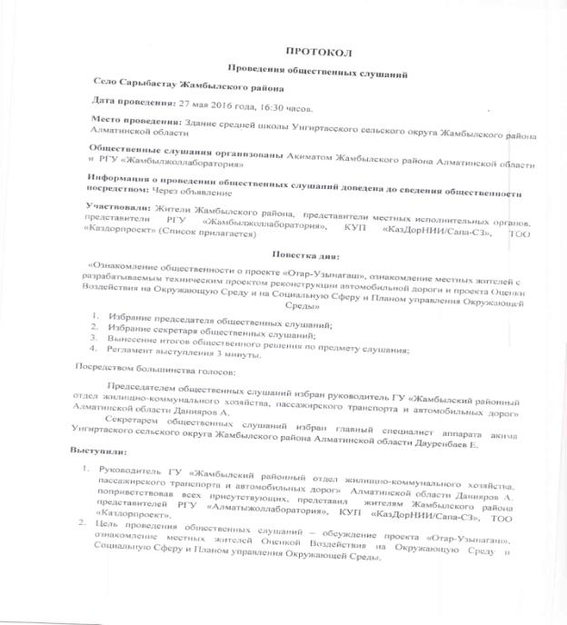

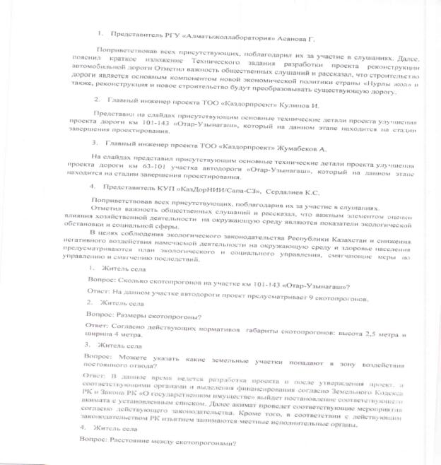

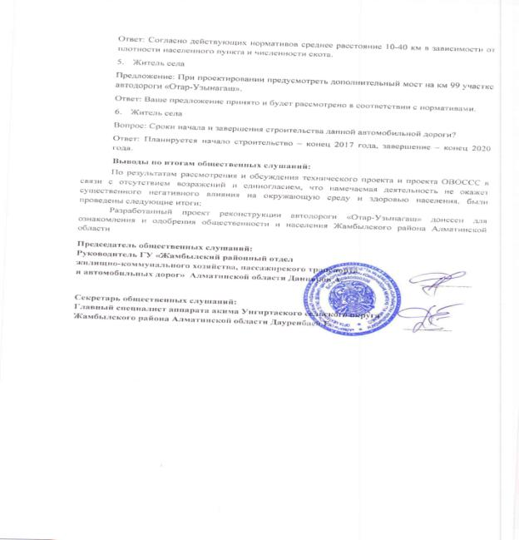

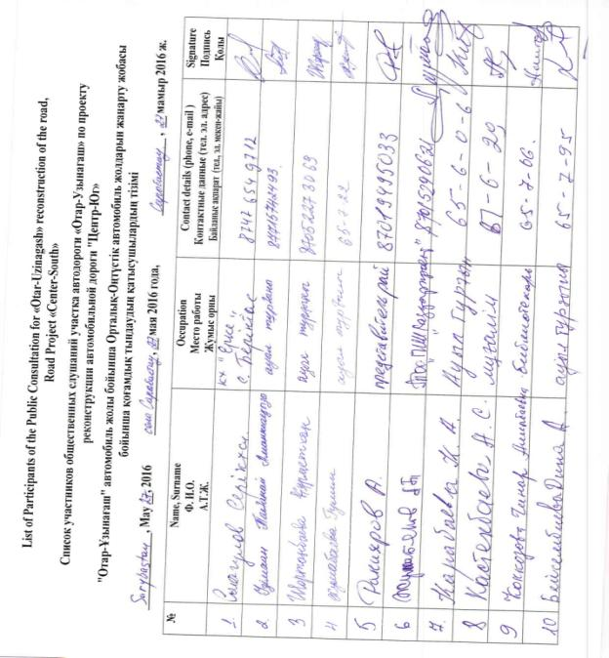

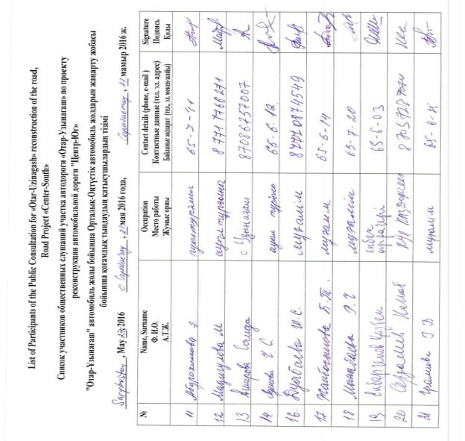

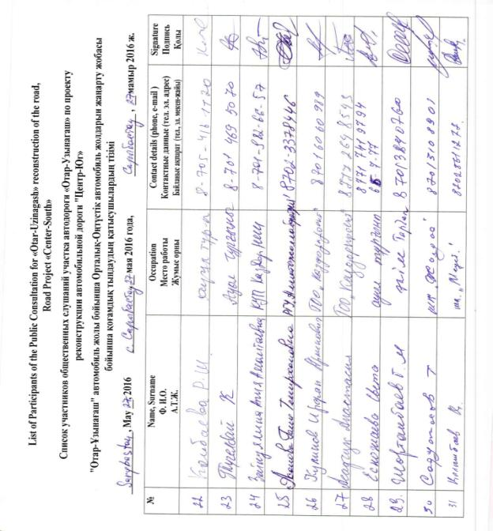

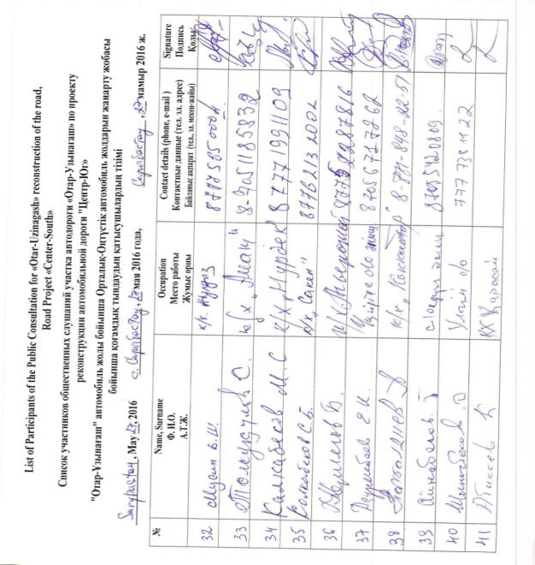

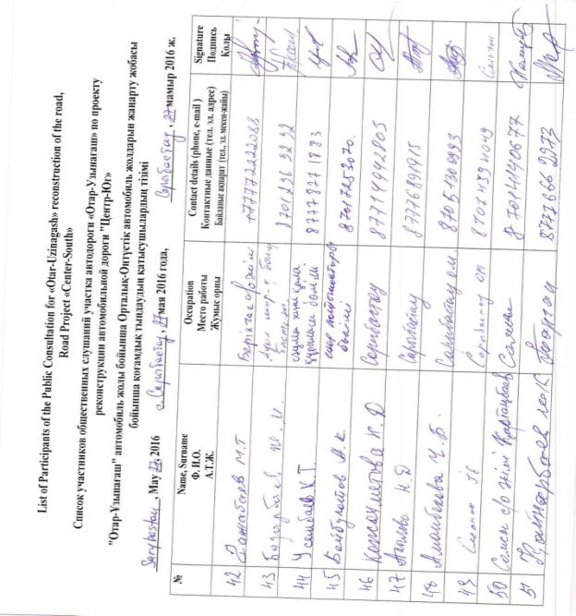

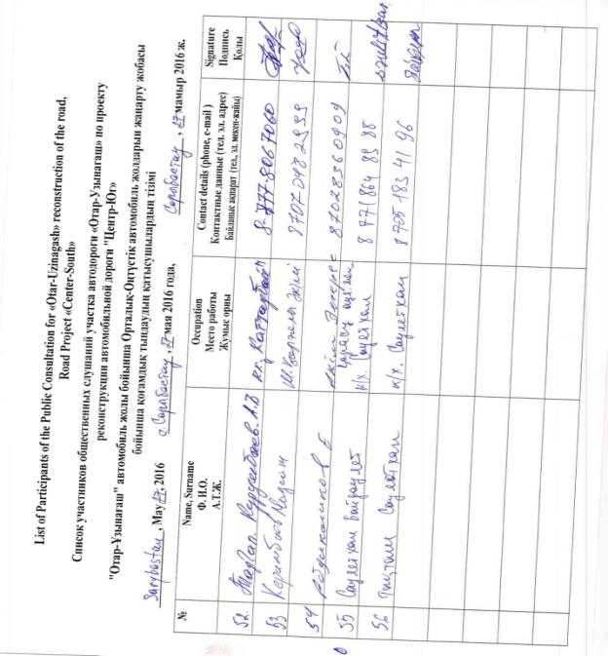

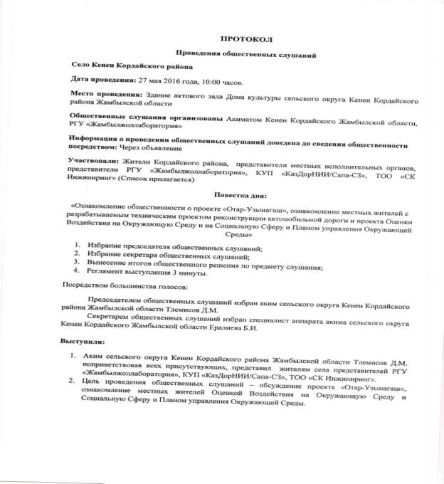

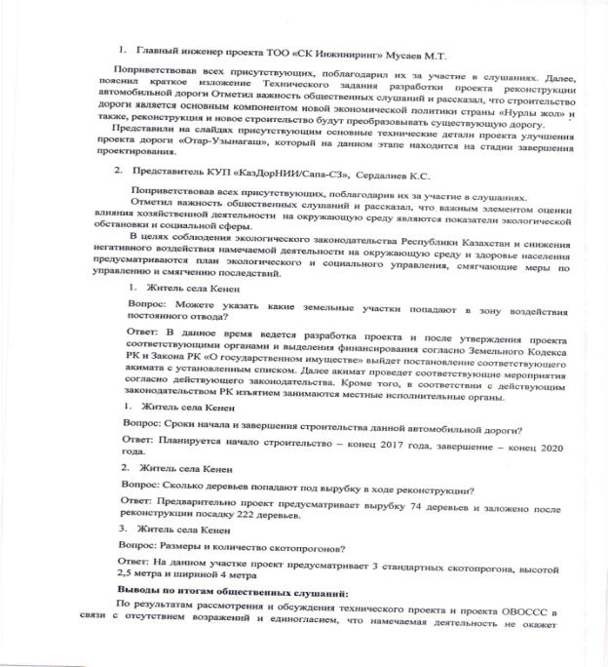

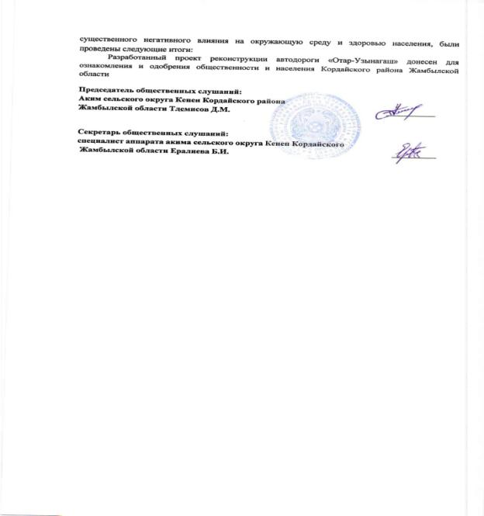

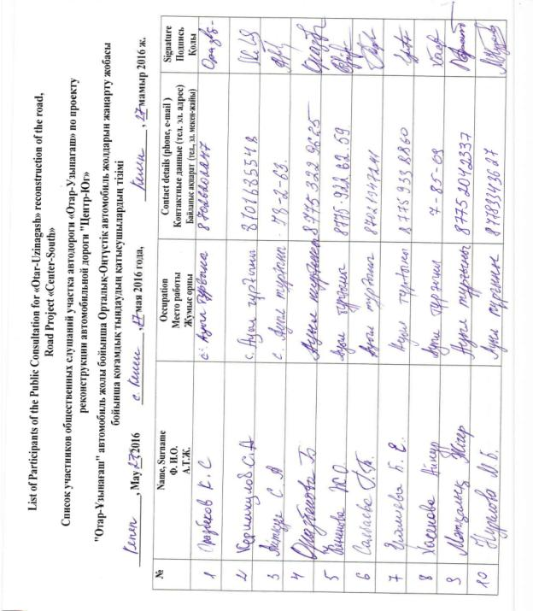

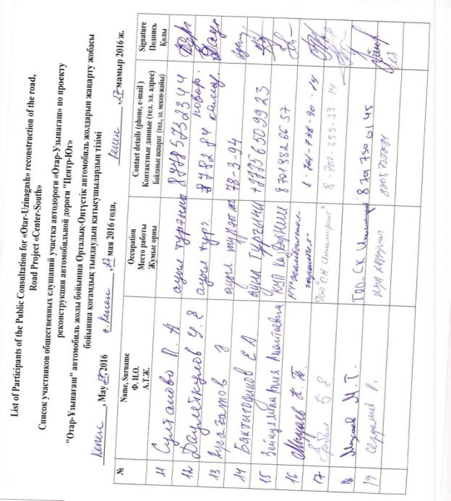

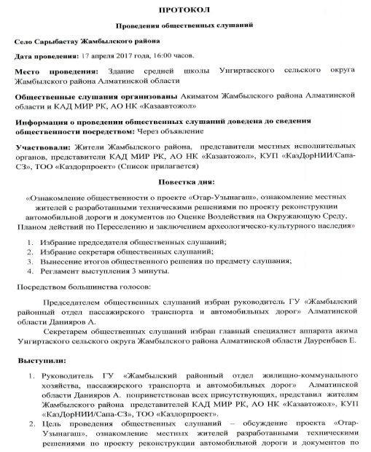

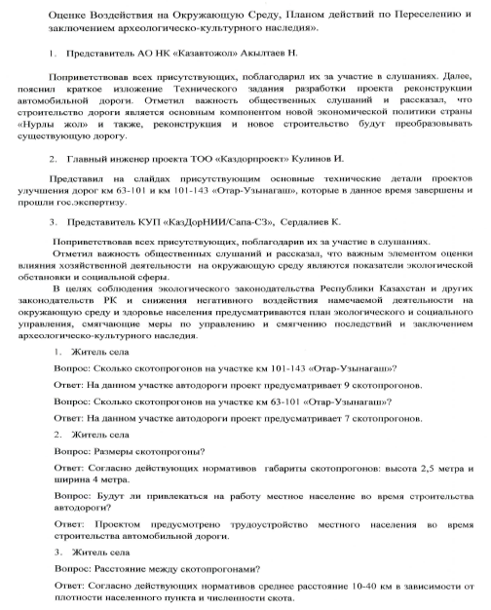

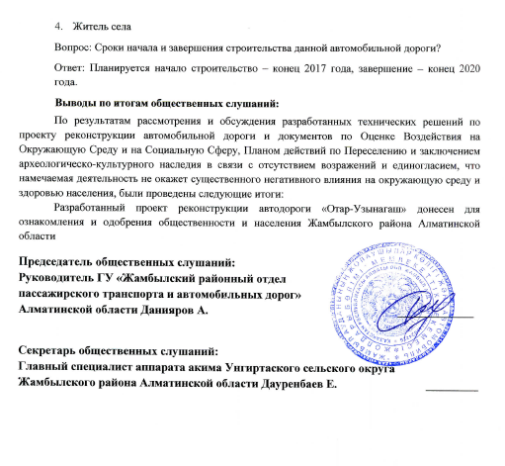

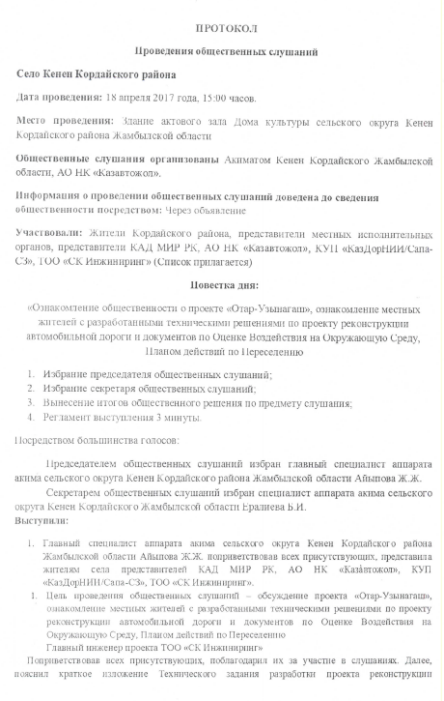

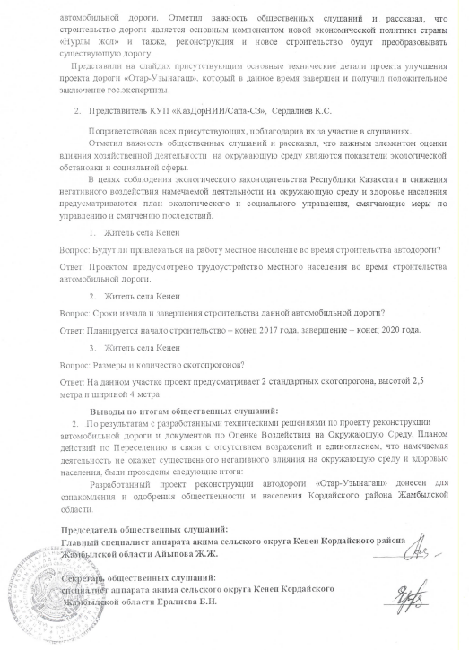

Annex 2.
Data on land plots affected by the Project
Uzynagash-Otar Road Project, km 63- km 159
No | Name of Landowner | Land Category | Ownership | Total Area, ha | Area to be Acquired, ha | % of acquisition  (0.00) | Type of Vegetation (Structures) | Compensation amount, in KZT | Note
1 | Olimp Center LLP | Commercial (for commercial development, fuel station) | Private property | 0.1000 | 0.1000 | 100 | There is a structure, no plants | 34,020,017.00 | Cash compensation
2 | Center-Asia LLP | Commercial (for commercial development) | Private property | 1.0000 | 0.7000 | 70 | Pasture (no structures, no plants) | 0 | Bare land plot, an alternative land plot is provided
3 | Dautbek Atanov | Agricultural (pasture) | Private property | 47.3000 | 2.0000 | 4.2 | Pasture (no structures, no plants) | 16,800.00 | Bare land plot, opted for cash compensation
4 | Sagatbek Sydykov | Agricultural (pasture) | Private property | 35.0000 | 0.8500 | 2.4 | Pasture (no structures, no plants) | 0 | Bare land plot, an alternative land plot is provided
5 | Zakhira Usakbayeva | Agricultural (pasture) | Private property | 140.0000 | 0.6500 | 0.5 | Pasture (no structures, no plants) | 0 | Bare land plot, an alternative land plot is provided
6 | Zheksebai Kali (three plots) | Commercial (for commercial development) | Private property | 2.0000 | 0.0200 | 1 | Undeveloped land, no structures, no plants | 3,836.00 | Bare land plot, opted for cash compensation
 |  | Commercial (for commercial development) | Private property | 0.4600 | 0.0900 | 19.6 | Undeveloped land, no structures, no plants | 27,544.00 | Bare land plot, opted for cash compensation
 |  | Commercial (for commercial development) | Private property | 0.7340 | 0.2200 | 30 | Undeveloped land, no structures, no plants | 40,920.00 | Bare land plot, opted for cash compensation
7 | Amankul Utegulova | Agricultural (pasture) | Private property | 100.0000 | 5.7000 | 5.7 | Pasture (no structures, no plants) | 123,120.00 | Bare land plot, opted for cash compensation
8 | Seidzhan Kaliyev | Agricultural (pasture) | Private property | 130.617 | 0.5000 | 0.4 | Pasture (no structures, no plants) | 4,200.00 | Bare land plot, opted for cash compensation
9 | Kattaubek Madiyarov | Agricultural (pasture) | Private property | 74.0000 | 0.1800 | 0.2 | Pasture (no structures, no plants) | 0 | Bare land plot, an alternative land plot is provided
10 | Danabek Bimenov | Agricultural (pasture) | Private property | 105.0000 | 0.5000 | 0.5 | Pasture (no structures, no plants) | 0 | Bare land plot, an alternative land plot is provided
11 | Bakitgul Aidarkulova | Agricultural (pasture) | Private property | 97.7000 | 4.5000 | 0.05 | Pasture (no structures, no plants) | 0 | Bare land plot, an alternative land plot is provided
12 | Ryskali Mirazov | Agricultural (pasture) | Private property | 586.2000 | 0.3000 | 0.05 | Pasture (no structures, no plants) | 0 | Bare land plot, an alternative land plot is provided
13 | Alen Iskander | Agricultural (pasture) | Private property | 115.0000 | 3.0000 | 2.6 | Pasture (no structures, no plants) | 36,450.00 | Bare land plot, opted for cash compensation
 | TOTAL: |  |  |  | 19, 3100 |  |  | 34,272,887.00

Commercial land is intended to be used for commercial development. However, the wide practice in the region includes situations when the land is obtained for commercial development, but nothing is constructed on it and it functions as natural pastures the same as agricultural lands. In this case two out of three commercial land plots allocated for commercial development are bare lands, used as pastures, no income earning or profit oriented business, no buildings or structures are in these lands. One land plot out of these three commercial plots was actually used for business activity, i.e. the fuel station has been constructed on it (Olimp Center LLP).
According to the Law ‘On Republican Budget for 2018-2019’ the rate of minimal monthly salary for 2018 is KZT28,784.00 per person.
The poverty line is determined as 40% of minimum subsistence level that is KZT28,784.00 as of 2018.
See footnote 1.
Information on the exact number of such employees is unavailable now, since it depends on the Contractor and the actual need in staff during construction works. Although this RAP does not provide this data, the contractors will develop Labor Camp Management Plan specifying details on staffing and outlining a range of mitigation measures designed to avoid/reduce undesired camp management impacts during construction and maintain constructive relationships between local communities and workers’ camps.
The category of this land plot is commercial, initially intended for commercial development of fuel station and car repair garage, however by the time of this project no building/structure had been constructed on this land plot and the land remained bare with also no agricultural income producing plantations. Land is used as natural pastures for freely moving and grazing livestock.
See footnote 6, the land plot was intended for construction of café, store and fuel station, but nothing constructed.
See footnote 6, the land plot was intended for construction of shopping center and motel, but nothing constructed.
See footnote 7.

